

CAPSTONE PROJECT REPORT
Report 6 – Software User Guides

– Hanoi, August 2026 –
Table of Contents
I. Record of Changes 3
II. Release Package & User Guides 4
1. Deliverable Package 4
2. Installation Guides 4
2.1 System Requirements 4
2.2 Installation Instruction 4
3. User Manual 4
3.1 Overview 4
3.2 Maternal Care Plan 6
3.2.1 Purpose of this Workflow: 6
3.2.2 Workflow Diagram: 6
3.2.3 Step-by-Step User Guide: 8
3.3 Baby Care Journey & Growth 14
3.3.1 Purpose of this Workflow: 14
3.3.2 Workflow Diagram: 15
3.3.3 Step-by-Step User Guide
Step 1: Create baby profile 16
3.4 Community Q&A & Moderation 20
3.4.1 Purpose of this Workflow: 20
3.4.2 Workflow Diagram: 21
3.4.3 Step-by-Step User Guide for Mother, family 21
3.4.4 Step-by-Step User Guide for Moderator 25
3.5 Verified Expert Network & Contribution 28
3.5.1 Purpose of this Workflow: 28
3.5.2 Workflow Diagram: 29
3.5.3 Step-by-Step User Guide on the Web: 30
3.5.4 Step-by-Step User Guide on the Mobile app: 34
3.6 AI Nurse Assistant & Risk Triage 42
3.6.1 Purpose of this Workflow: 42
3.6.2 Workflow Diagram: 43
3.6.3 Step-by-Step User Guide 44
3.7 Emergency Map Nearby Support 48
3.7.1 Purpose of this Workflow: 48
3.7.2 Workflow Diagram: 49
3.7.3 Step-by-Step User Guide 49

I. Record of Changes
Date | A*  M, D | In charge | Change Description
11/8/2026 | A | BachNQ | Add 1. Deliverable Package
11/8/2026 | A | BachNQ | Add 2. Installation Guides
11/8/2026 | A | HuyND | Add User manual
11/8/2026 | A | PhuongNT | Add User manual
*A - Added M - Modified D - Deleted

II. Release Package & User Guides

1. Deliverable Package
No. | Deliverable Item | Description
1 | Project Schedule/Tracking | Project Tracking - SEP490-G79-CareBridge
2 | Source Codes | https://gitlab.com/manhnc2/su26_sep490_g79
4 | Database Script(s) | 05_Development\Database\carebridge_full_schema.sql
5 | Final Report Document | Report7_Final Project Report
6 | Test Cases Document | Report5.0_Test Documentation
7 | Slide | https://canva.link/ksodtrge2vvbrfy

2. Installation Guides

2.1 System Requirements
● Mobile App: The mobile app requires an Android phone to run.
● Web (Operator): The web app requires a valid, up-to-date web browser for access.

2.2 Installation Instruction
● Mobile App: Download and install the APK file to gain access to the mobile application.
● Web (Operator): Access the web application by navigating to the designated URL using a supported web browser. Ensure that you have the necessary login credentials to proceed.

3. User Manual

3.1 Overview
CareBridge is a community-driven maternal and early childhood healthcare platform designed to support users throughout the care journey from preconception, pregnancy, and postpartum recovery to early childhood care. The platform provides personalized care support, reliable health information, health records, reminders, monitoring, expert support, and family cooperation.
CareBridge is developed as a digital platform that complements existing healthcare services rather than replacing healthcare professionals. Its objective is to improve continuity of care, access to trusted health information, personalized health management, and timely safety-oriented support for mothers, children, and families.
The following functional groups support the main user needs throughout the care journey:
- Account, Trust & Access Control:
Manages accounts, roles, sessions, consent, notification preferences, and access to sensitive health information.
- Mother Care Journey:
Supports preconception, pregnancy, and postpartum care.
Manages health records, health indicators, pregnancy tracking, reminders, and care tasks.
- Baby Care Journey, Growth & Vaccination:
Manages baby profiles, feeding/sleep/diaper journals, growth, milestones, health records, and vaccination records.
- Community Q&A & Moderation:
Provides topic-based questions and answers, expert labels, reporting, moderation, and community governance.
- Verified Expert Network:
Manages expert profiles, credential verification, specialties, availability, and expert contributions.
- AI Nurse Assistant & Risk Triage:
Collects symptom information and provides non-diagnostic risk orientation and safe next-step guidance.
- Emergency Map & Nearby Care:
Provides nearby healthcare facilities, routes, ETA, and quick call/navigation support.
- Family Sync & Cooperative Care:
Allows family members to join care groups and share permitted health information, calendars, and alerts.
- Verified Content & Checklist Hub:
Provides reviewed health articles, FAQs, and stage-based checklists with source and review information.
- Smart Activity Monitoring & Safety Support:
Uses phone motion sensors, with consent, to detect suspected falls or impacts and notify selected contacts.

3.2 Maternal Care Plan

3.2.1 Purpose of this Workflow:
This workflow helps mothers create and manage a personalized maternal care journey based on their current lifecycle stage: preconception, pregnancy, or postpartum. CareBridge provides stage-aware dashboards, approved health content, checklists, exercise guidance, appointment preparation, reminders, and tools for recording maternal health indicators, symptoms, mood, and recovery notes.
The workflow preserves the source and history of recorded information so that mothers can review their health timeline and prepare for discussions with healthcare professionals. CareBridge supports health tracking and reviewed guidance only. It does not diagnose medical conditions, assess medical fitness, or replace professional medical advice. If a serious or emergency symptom occurs, the user should contact an appropriate healthcare facility immediately.

3.2.2 Workflow Diagram:

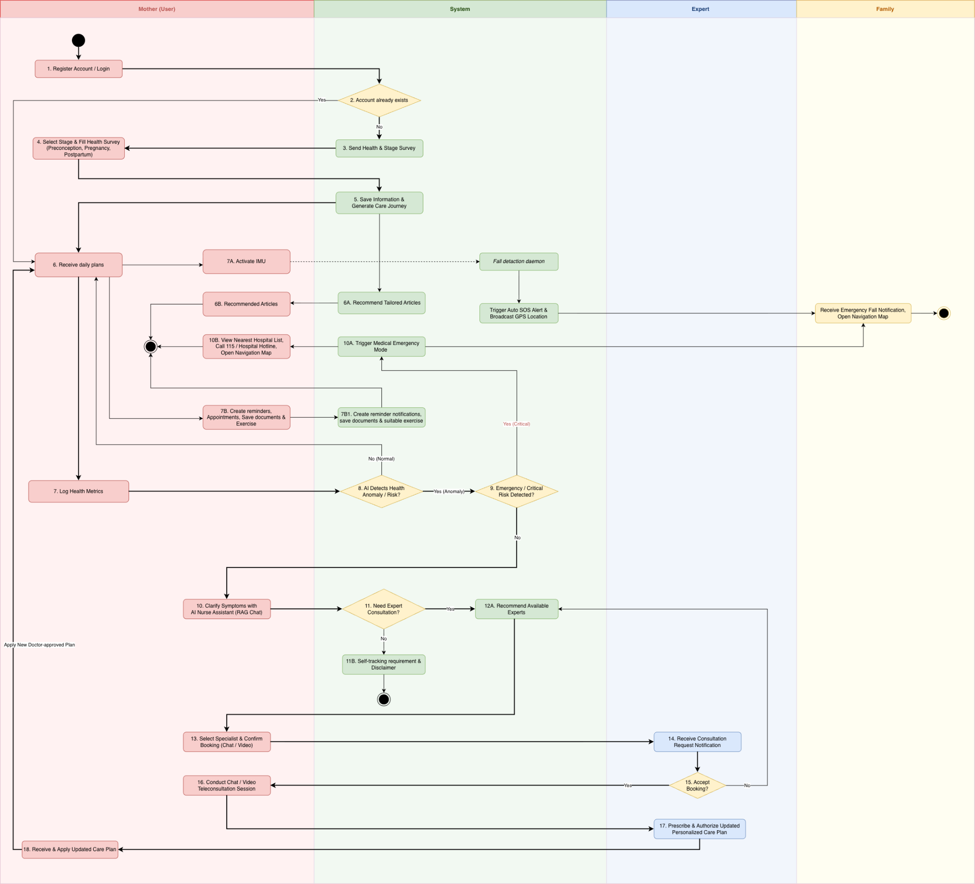
Image Detail: Maternal Care Plan Workflow

3.2.3 Step-by-Step User Guide:
Step 1: Register or Log in to the Account
- Open the CareBridge application and select Register to create a new account, or select Log in when an account already exists.
- For registration, enter the required account and personal information, then complete the verification process if requested.
- Enter the login credentials and select Log in.
- After successful authentication, the user is taken to the maternal care flow and can begin setting up a care journey.
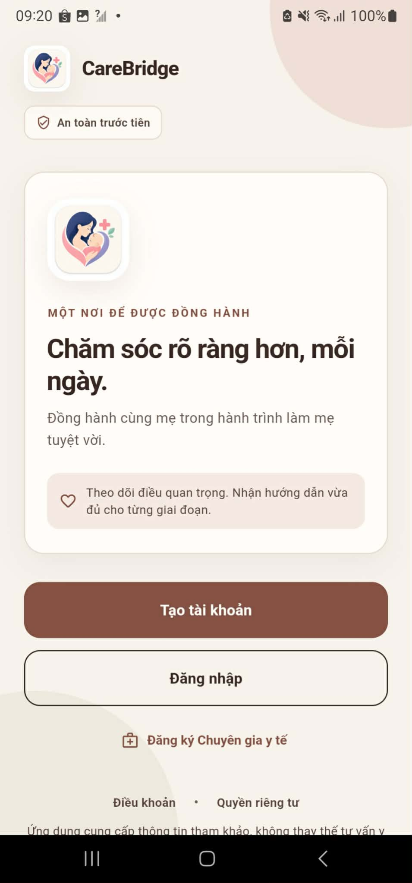
Step 2: Select the Maternal Stage
- Open the maternal care setup screen after logging in.
- Select the stage that matches the user's current situation: Preconception, Pregnancy, or Postpartum.
- If Pregnancy is selected, provide the requested pregnancy information, such as the current pregnancy stage or related date.
- Review the selected stage and continue to the health survey.
- The system uses this selection to provide relevant questions, recommendations, and daily care content.
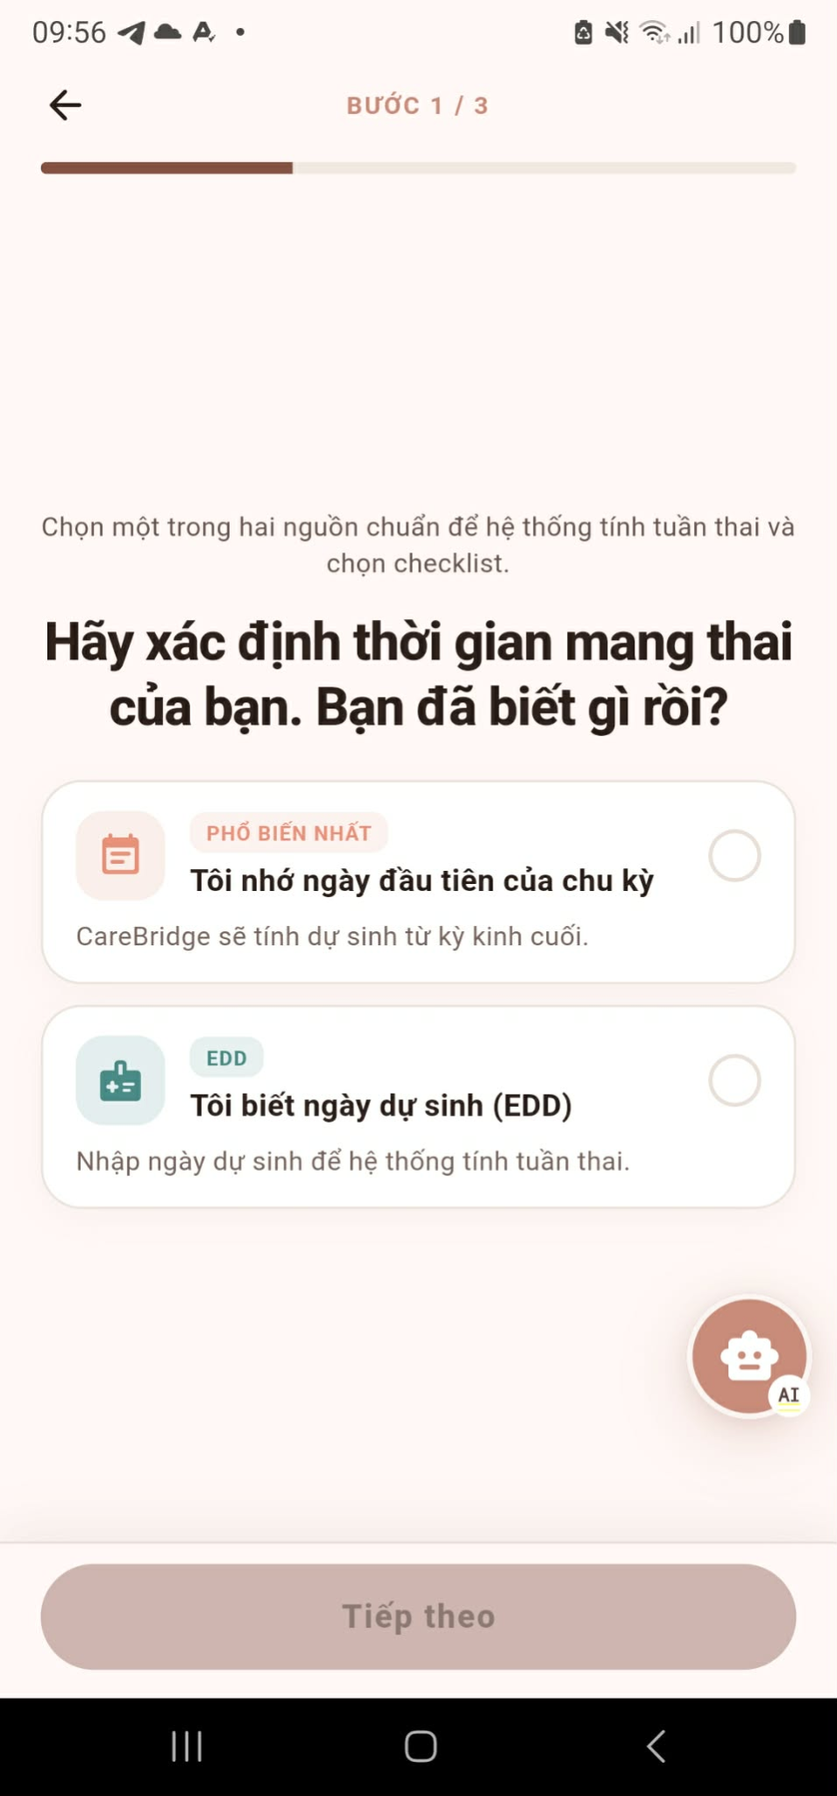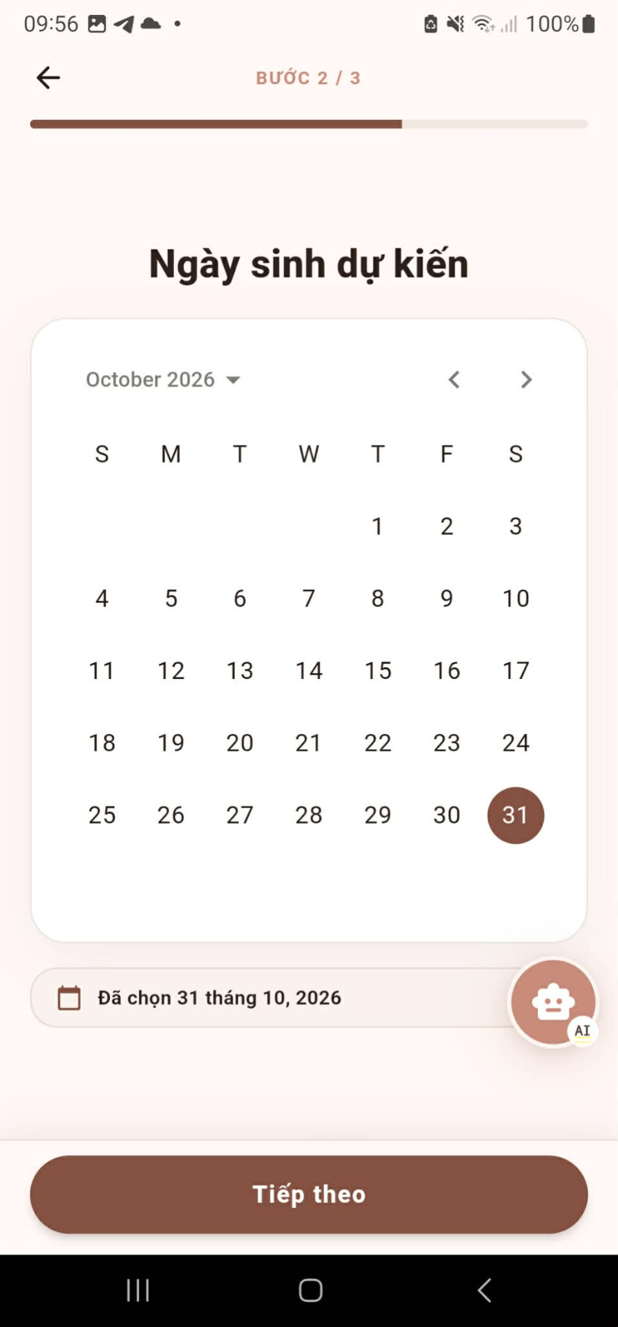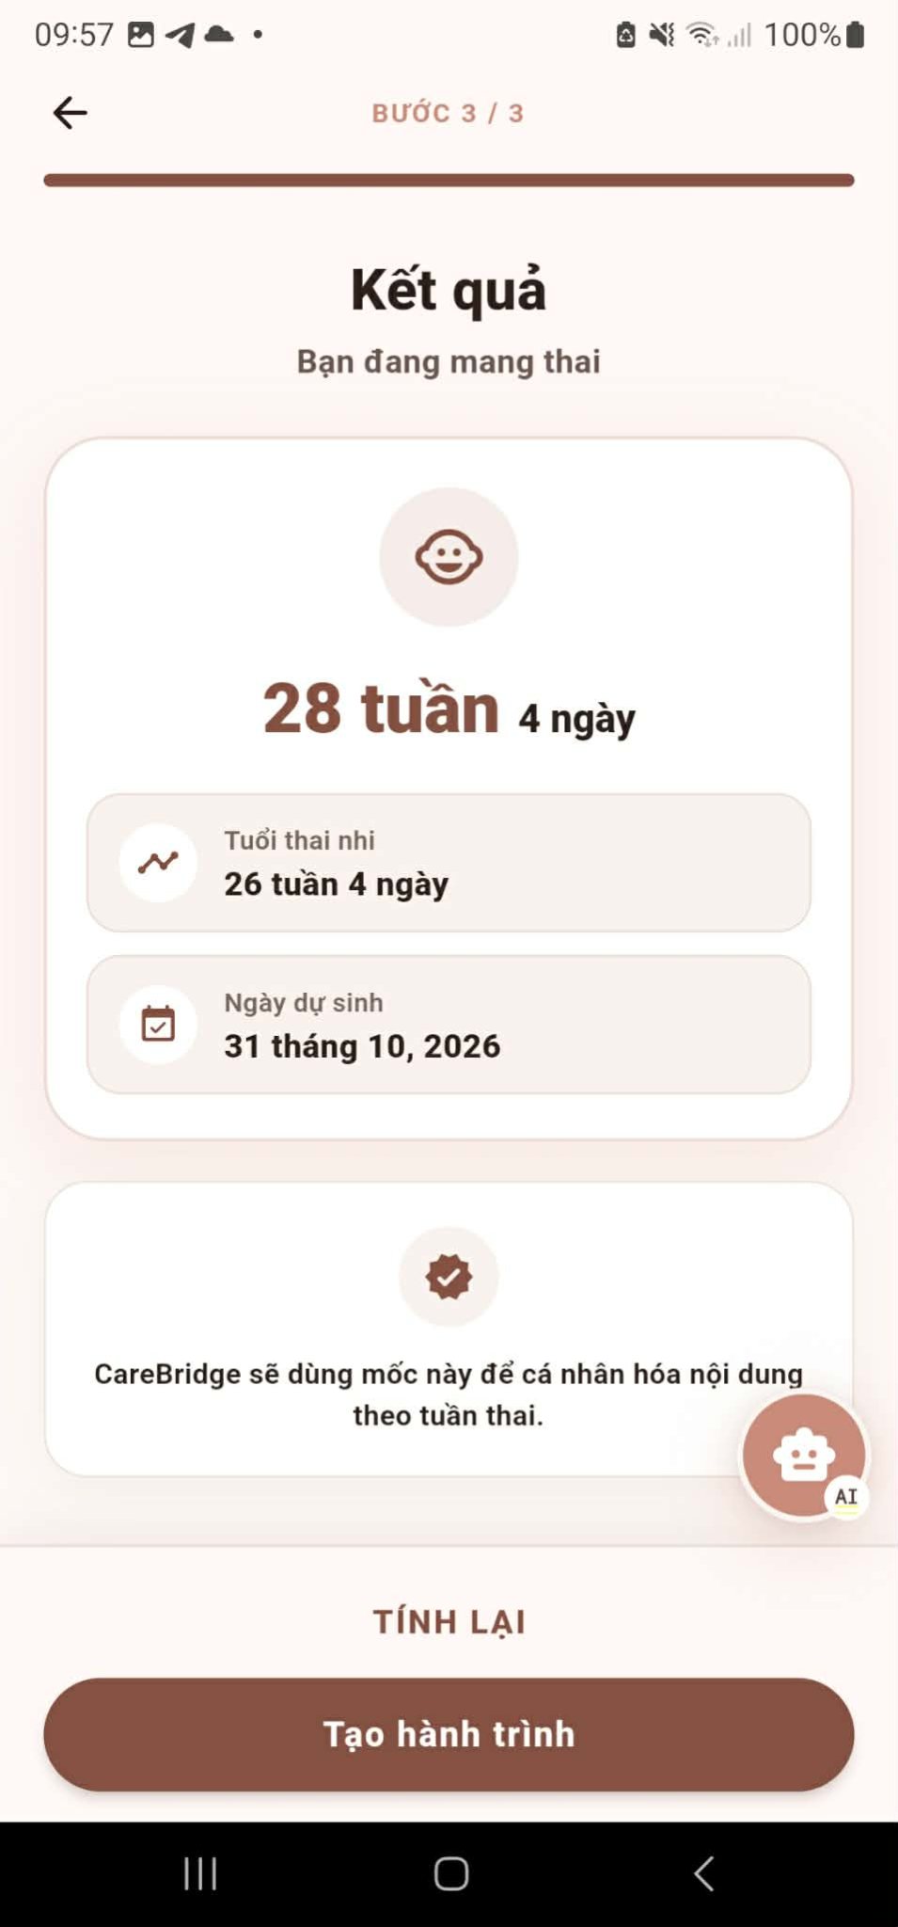
Step 3: Complete and Submit the Health Survey
- Read each health survey question related to the selected maternal stage.
- Enter or select the requested information about the user's health condition, lifestyle, symptoms, and care needs.
- Complete all required fields before continuing.
- Review the answers and correct any information that is inaccurate or incomplete.
- Submit the survey.
- The system saves the health information and uses it to generate a personalized care journey.

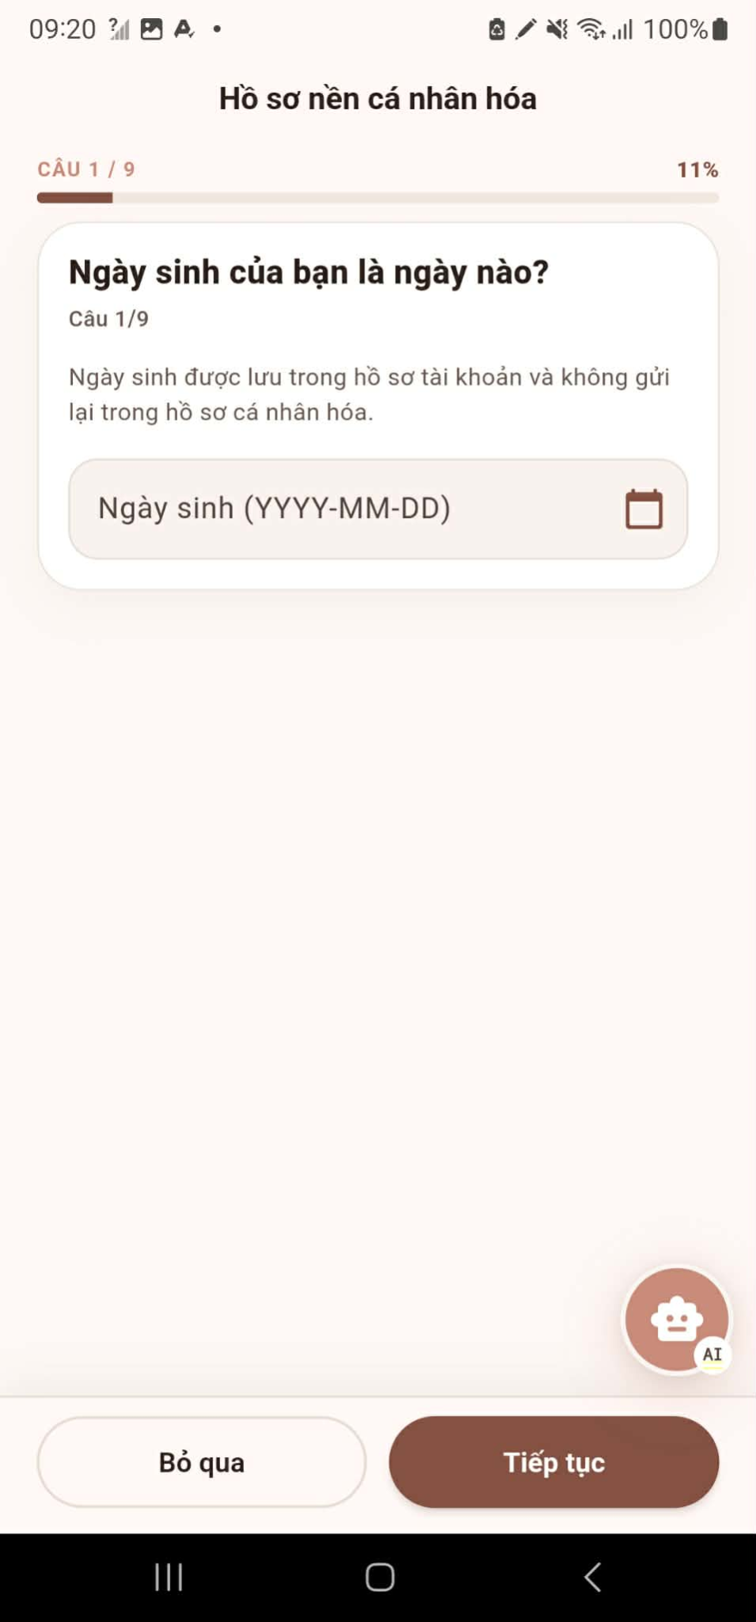

Step 4: Review the Generated Daily Care Plan
- After the survey is submitted, open the generated care plan.
- Review the recommendations for the selected maternal stage.
- Check the daily tasks, health information, reminders, exercises, and verified content provided by the system.
- Select a plan item to view its details or mark an activity as completed when the task has been performed.
- Return to the daily plan regularly to follow the recommended care journey.
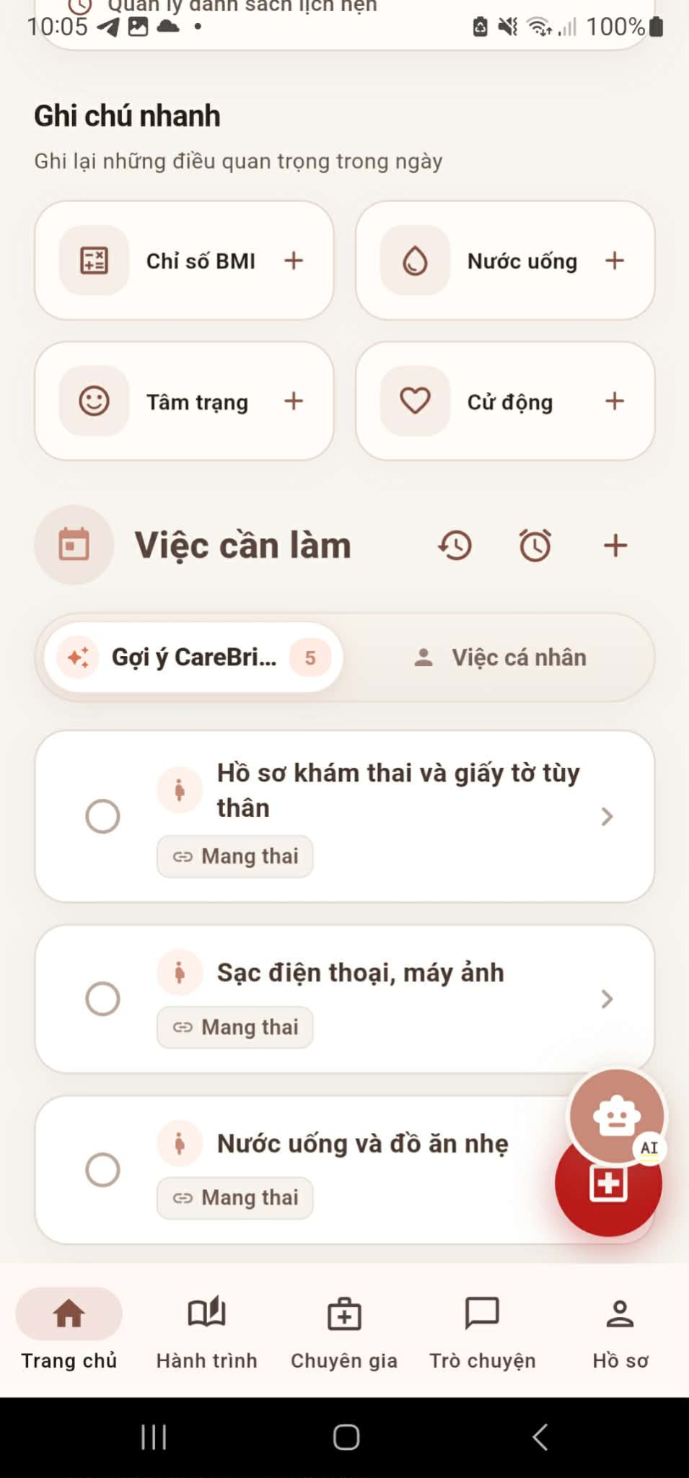
Step 5: Track and Manage Daily Care
- Record the required health metrics according to the daily plan.
- Review upcoming reminders and manage them when the schedule or care needs change.
- Open the pregnancy exercise section and follow the recommended exercises when appropriate.
- Read verified maternal health content related to the current stage.
- Mark completed activities so the system can update the user's progress.
- Continue monitoring the daily plan and check whether any health concern or warning is detected.
- If no health concern is detected, continue the daily care journey. If a concern is detected, proceed to Step 6.
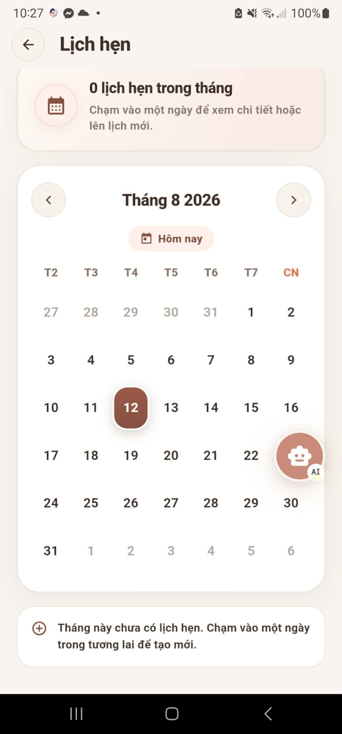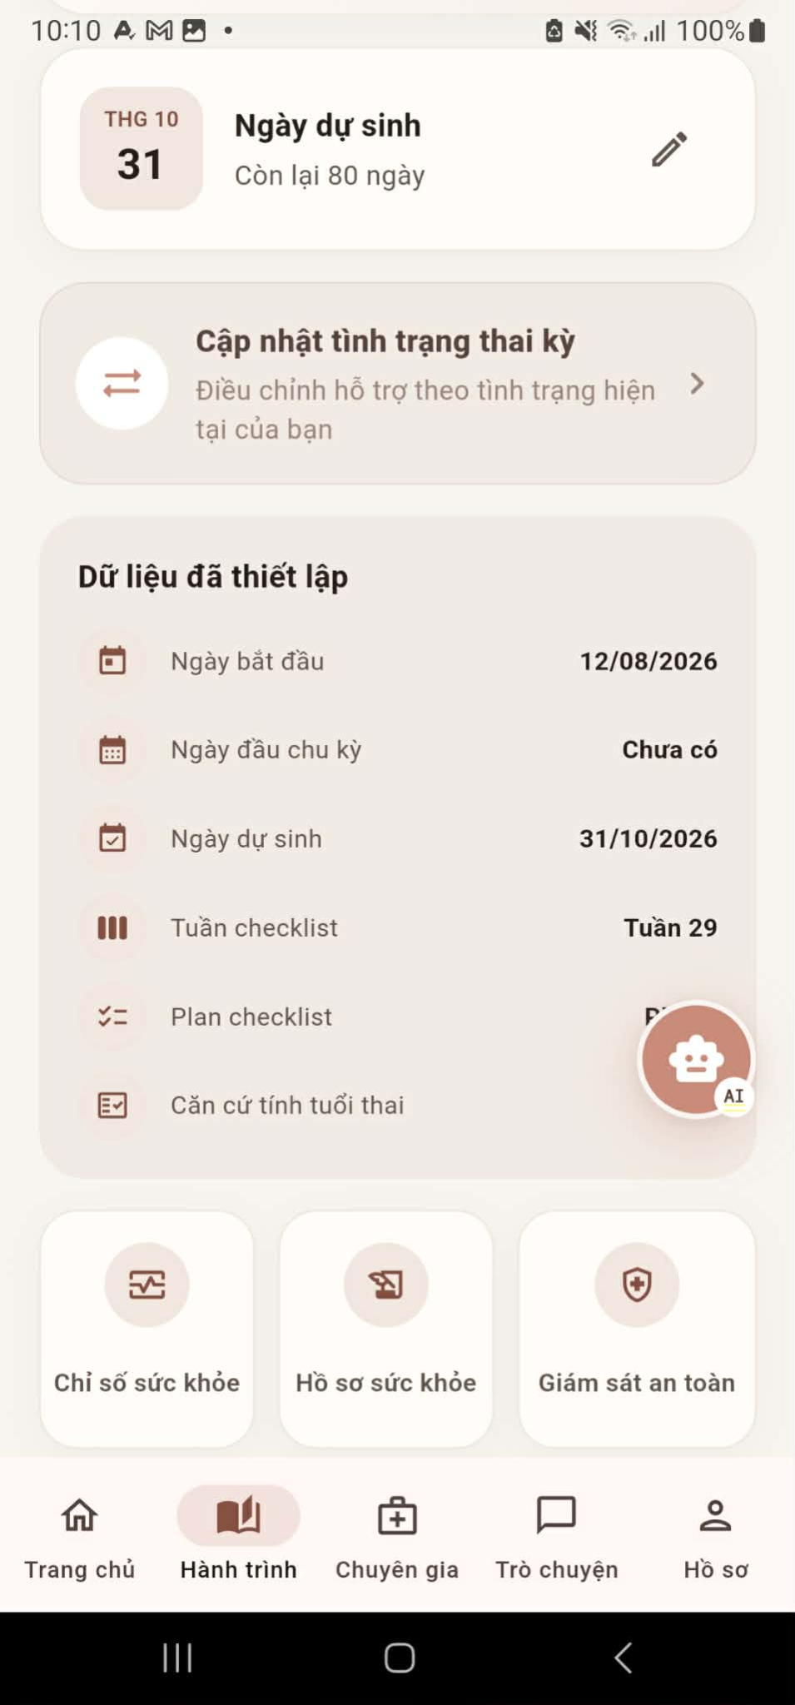
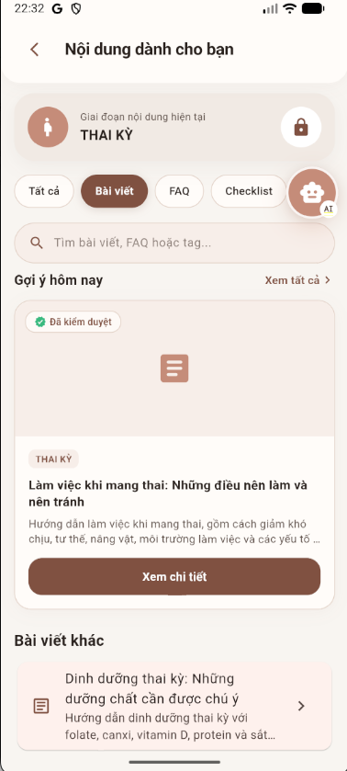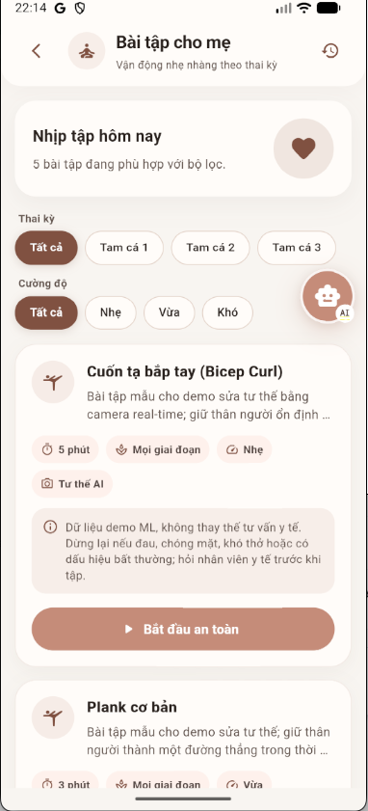
Step 6: Get AI Nurse Triage for a Health Concern
- Open AI Nurse Triage when a health concern is detected or when the user needs help assessing a symptom.
- Read the disclaimer and confirm that the information provided by the feature is for guidance and does not replace professional medical diagnosis.
- Describe the symptom or health concern and answer the follow-up questions shown by the system.
- Submit the information for assessment.
- The system evaluates the information using the triage service and safety rules.
- Review the result, urgency level, and recommended next action.
- Follow the guidance. Depending on the result, the user may continue self-care, seek urgent medical support, or proceed to Step 7 to request an expert consultation.
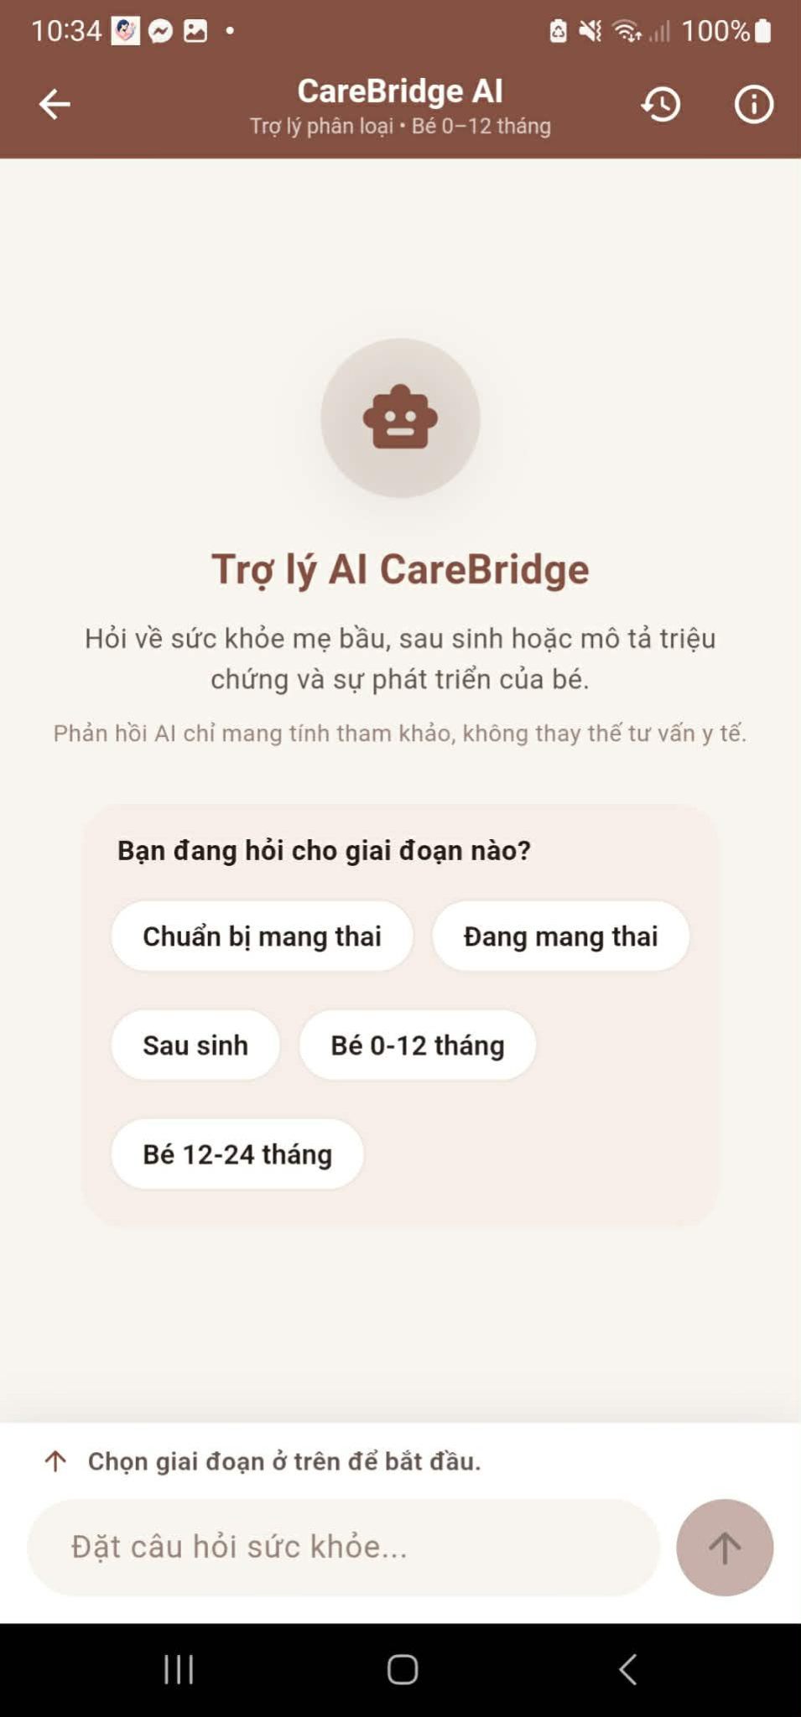
Step 7: Book an Expert Consultation and Receive a Personalized Plan
- When the triage result indicates that expert support is needed, open the expert consultation option.
- Review the available experts and their professional information.
- Select a suitable expert and choose an available consultation time or consultation method.
- Submit the booking request and wait for the expert to accept it.
- After the request is accepted, join the consultation through chat, voice, or video according to the available option.
- Share the relevant health information and discuss the concern with the expert.
- Review the personalized care plan provided after the consultation and follow the recommended actions.
- Continue tracking the user's health and return to the daily care plan for follow-up activities.
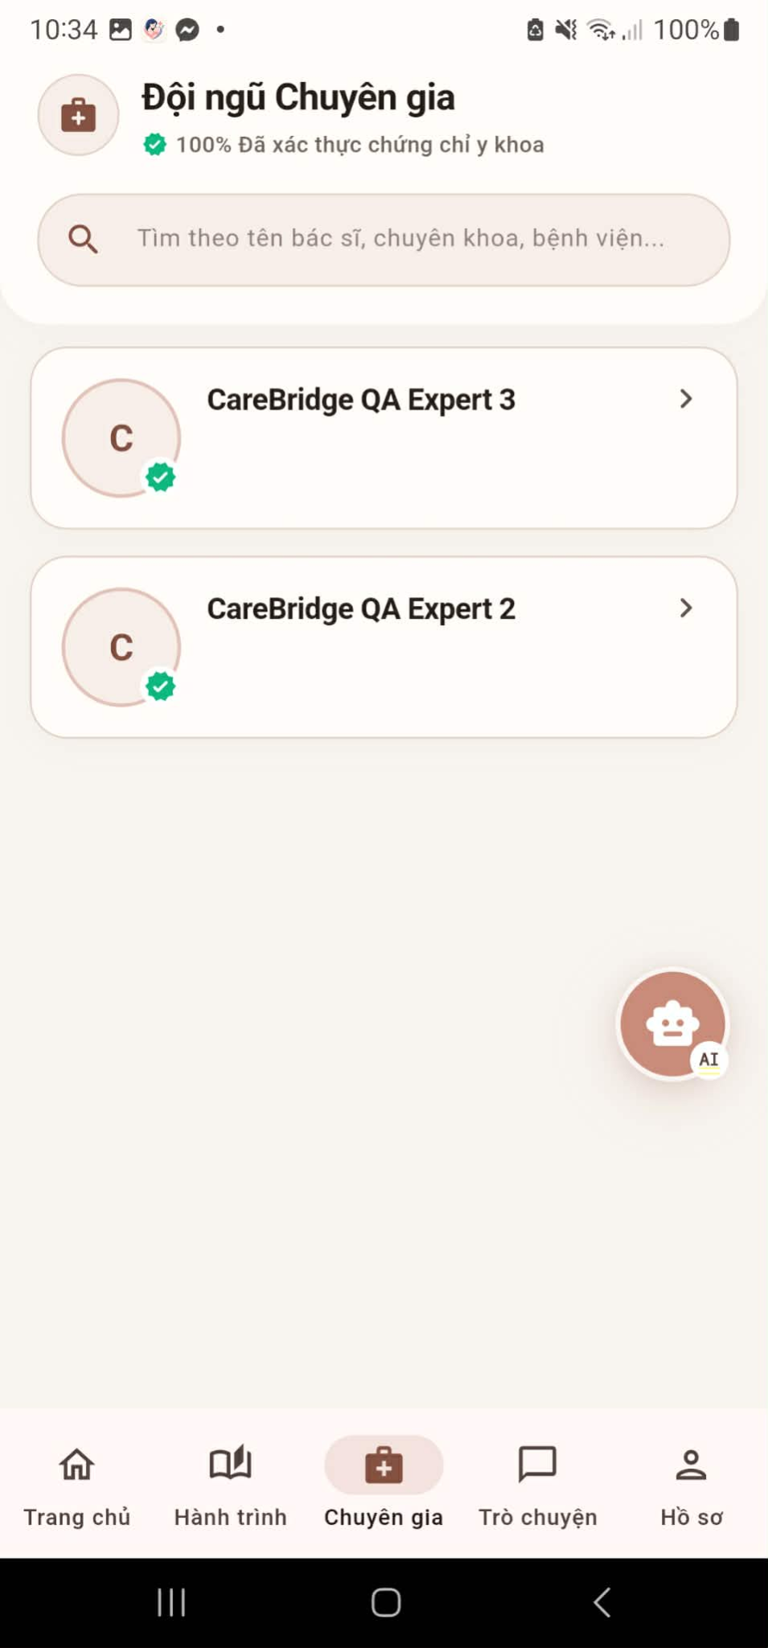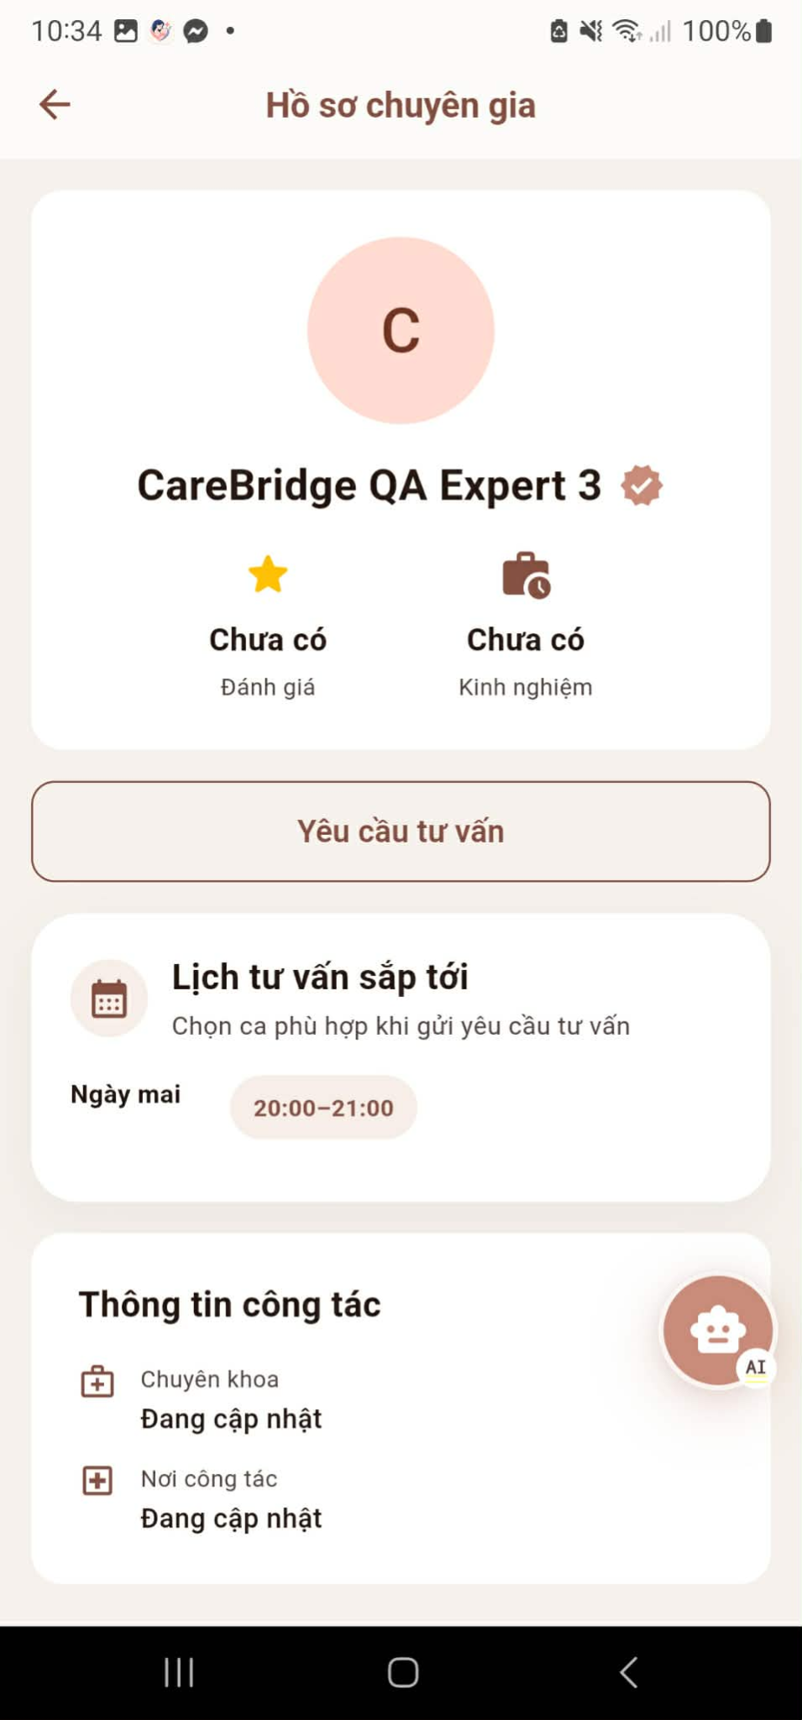

3.3 Baby Care Journey & Growth

3.3.1 Purpose of this Workflow:
This workflow helps mothers and caregivers create and manage baby profiles, receive age-appropriate baby-care guidance, record daily activities, monitor growth measurements and developmental milestones, and manage vaccination information. CareBridge stores the baby’s journals, measurements, milestones, and vaccination records in a traceable timeline so that caregivers can review changes over time and prepare for healthcare appointments. Age- and stage-based reference labels are provided for observation and general guidance only. This workflow does not diagnose medical conditions, assess developmental disorders, or replace advice from a qualified pediatrician.

3.3.2 Workflow Diagram:
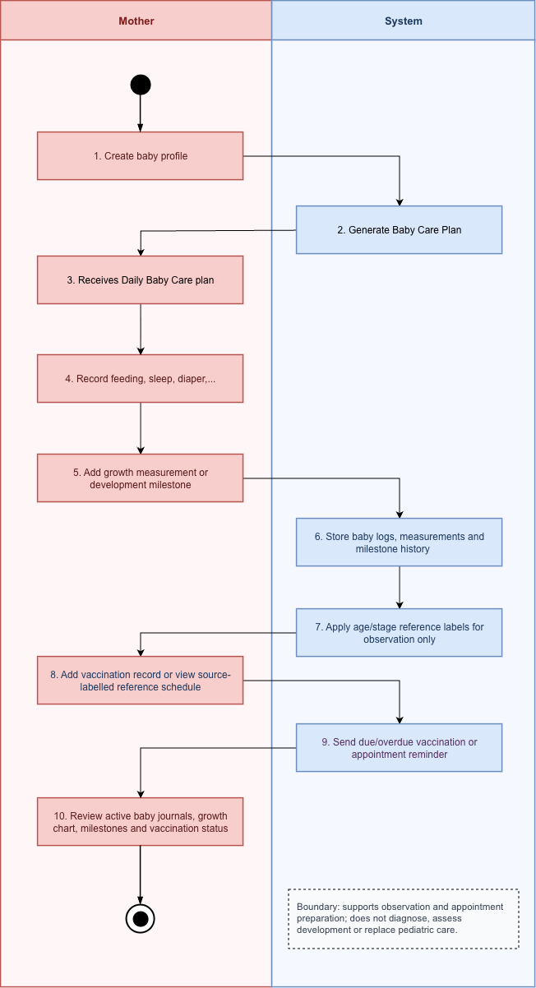
Image Detail: Baby Care & Growth Workflow

3.3.3 Step-by-Step User Guide
Step 1: Create baby profile
- Open the CareBridge mobile application and select Hành trình - Bé.
- Select Thêm hồ sơ bé.
- Enter the baby’s basic information, including nickname, date of birth, gender, birth weight, and birth length.
- Add a profile photo if required.
- Review the privacy notice. Baby information is protected and is used to calculate growth references and vaccination reminders.
- Select Lưu hồ sơ.
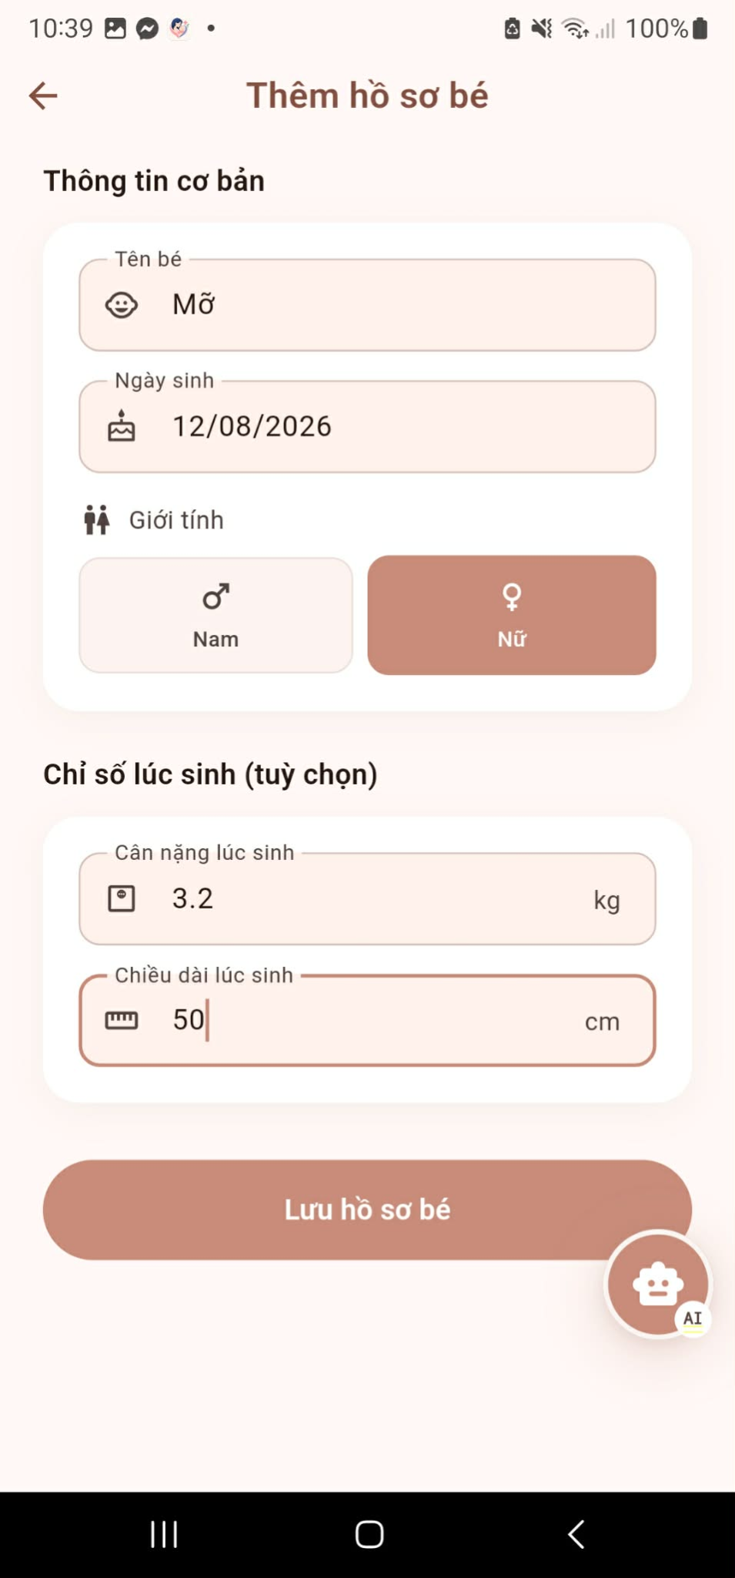
Step 2: Receives Daily Baby Care plan
- After the baby profile is saved, CareBridge generates a daily baby-care plan based on the baby’s age and available profile information.
- Open the “Trang chủ” to view the recommended daily activities and reminders.
- Review the plan and any available notifications, such as feeding, sleep, appointment, or vaccination reminders.
- Use the plan as a tracking and preparation tool. The recommendations are general references and should not be treated as a medical diagnosis or treatment plan.


Step 3: Record feeding, sleep, diaper, symptom or night-mode journal
- Open the active baby profile and select the relevant journal function.
- Select the type of journal to record, such as Feeding, Sleep, Diaper, Symptoms, or Night Mode.
- Enter the event details. Depending on the journal type, this may include:
- Feeding amount, feeding duration, feeding side, or food type.
- Sleep start time, end time, and sleep status.
- Diaper type and observations.
- Symptoms, baby’s condition, and additional notes.
- Night-mode events recorded during nighttime care.
- Add a note or photo when additional context is useful.
- Select Save Journal.
- To review a previous entry, open the baby’s daily log summary and select the relevant event.
- Select Edit to update an entry or Delete Journal to remove it. Deleted records cannot be recovered.

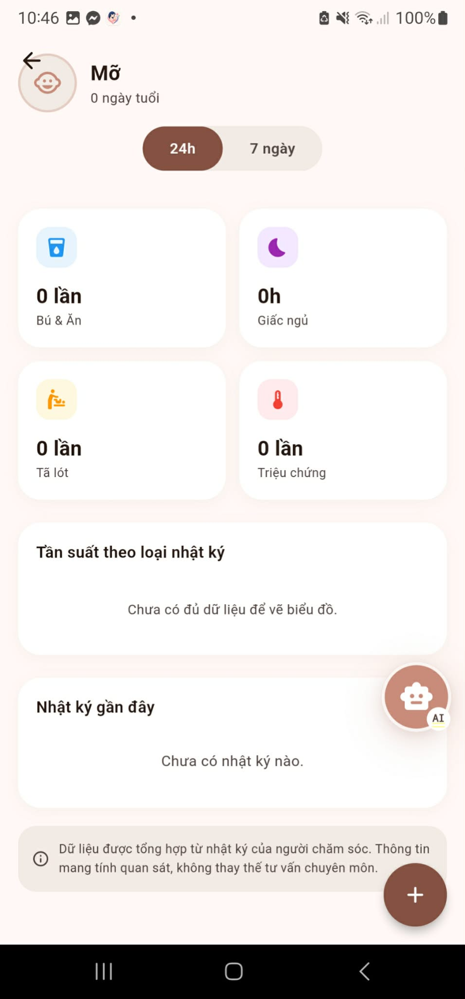
Step 4: Add growth measurement or development milestone
- Open the active baby profile and select Tăng trưởng.
- Select Thêm mốc phát.
- Enter the measurement date and time.
- Enter the available measurements:
- Add an optional note, such as the measurement conditions or observations.
- Select Lưu mốc phát triển.
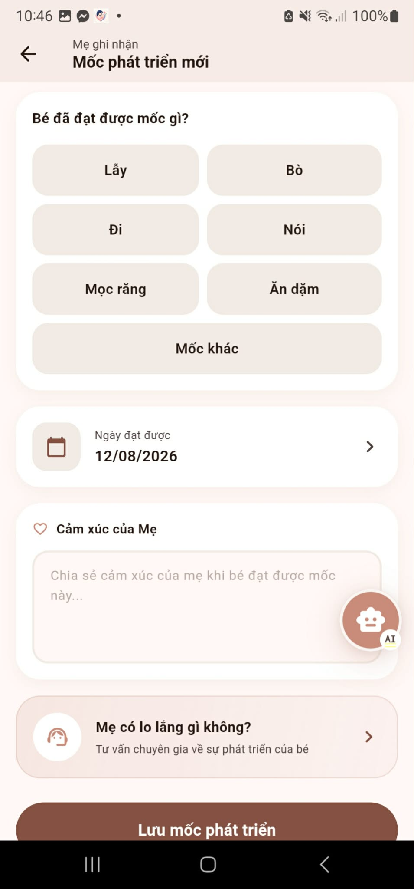
Step 5: Add vaccination record or view source-labelled reference schedule

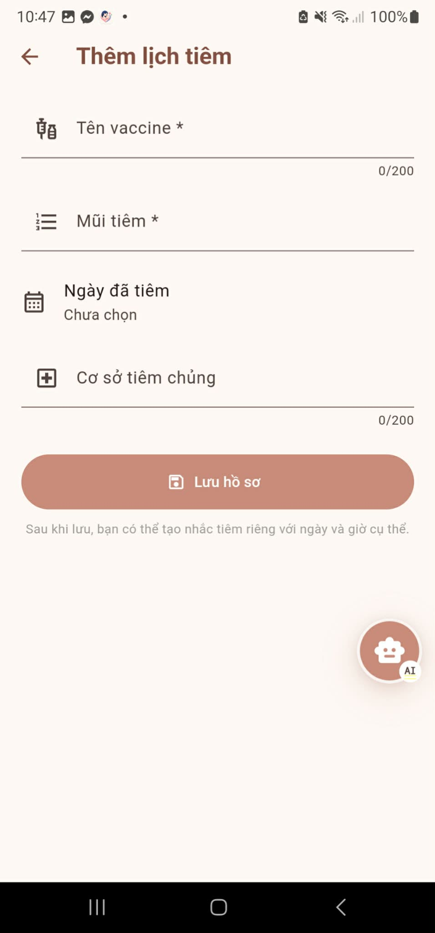

3.4 Family Sync

3.4.1 Purpose of this Workflow:

3.4.2 Workflow Diagram:
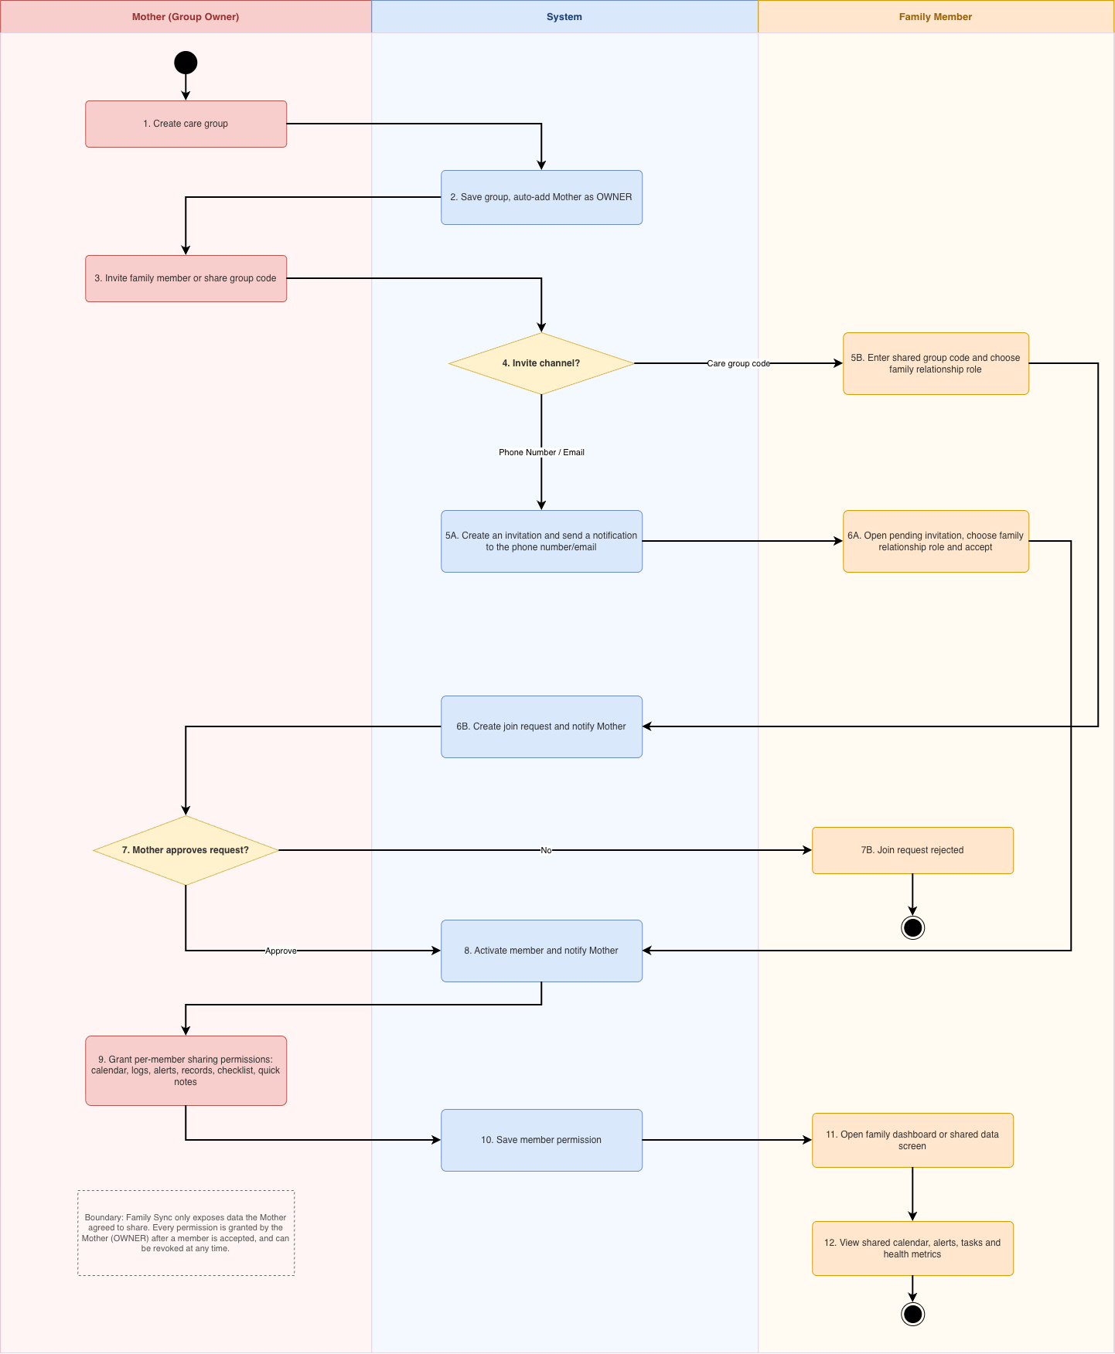
Image Detail: Family Sync Workflow

3.4.3 Step-by-Step User Guide for Mother
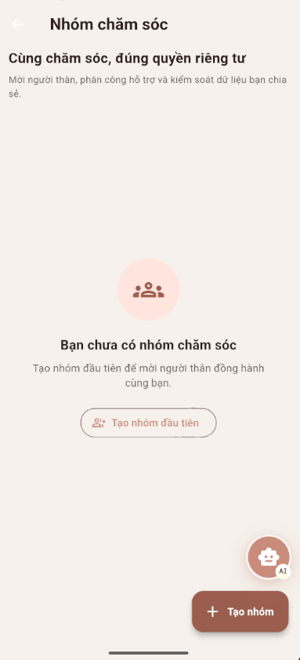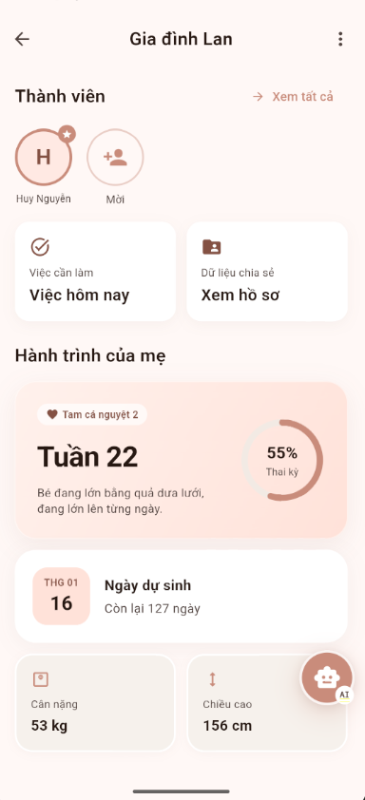
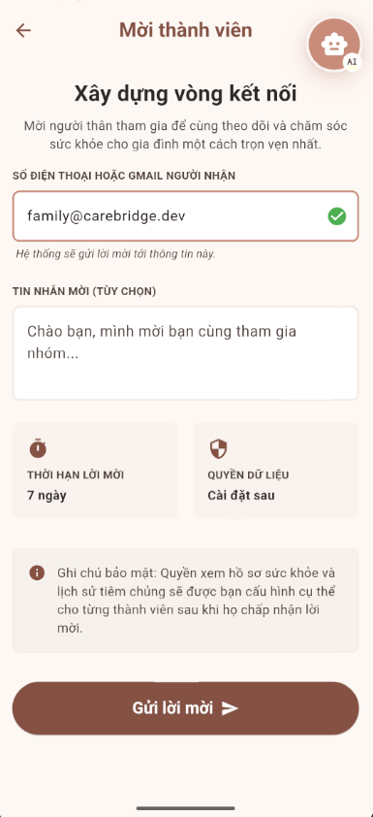
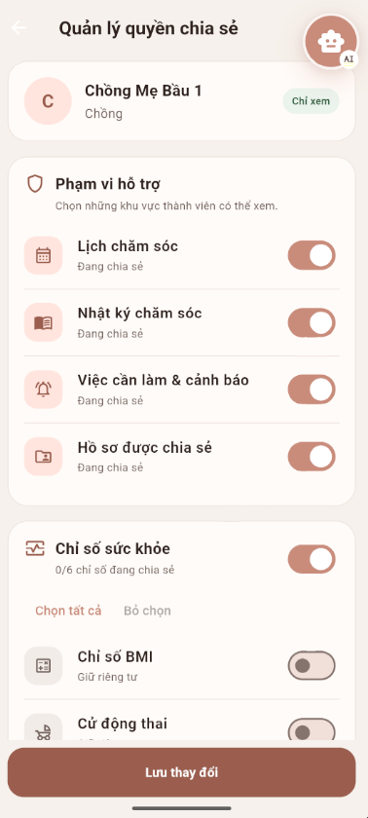

3.4.4 Step-by-Step User Guide for Family Member
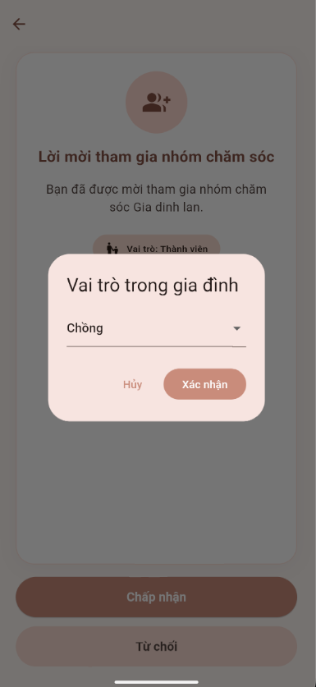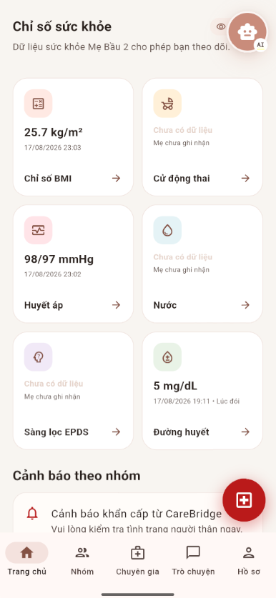

3.5 Community Q&A & Moderation

3.5.1 Purpose of this Workflow:
It allows mothers, family members, and verified professionals to share health-related questions, answers, and experiences. The system scans submitted content for potential policy violations, while Community Moderators review flagged items to decide whether the content should be published, edited, hidden, or rejected. Users receive notifications regarding the final status of their content.

3.5.2 Workflow Diagram:
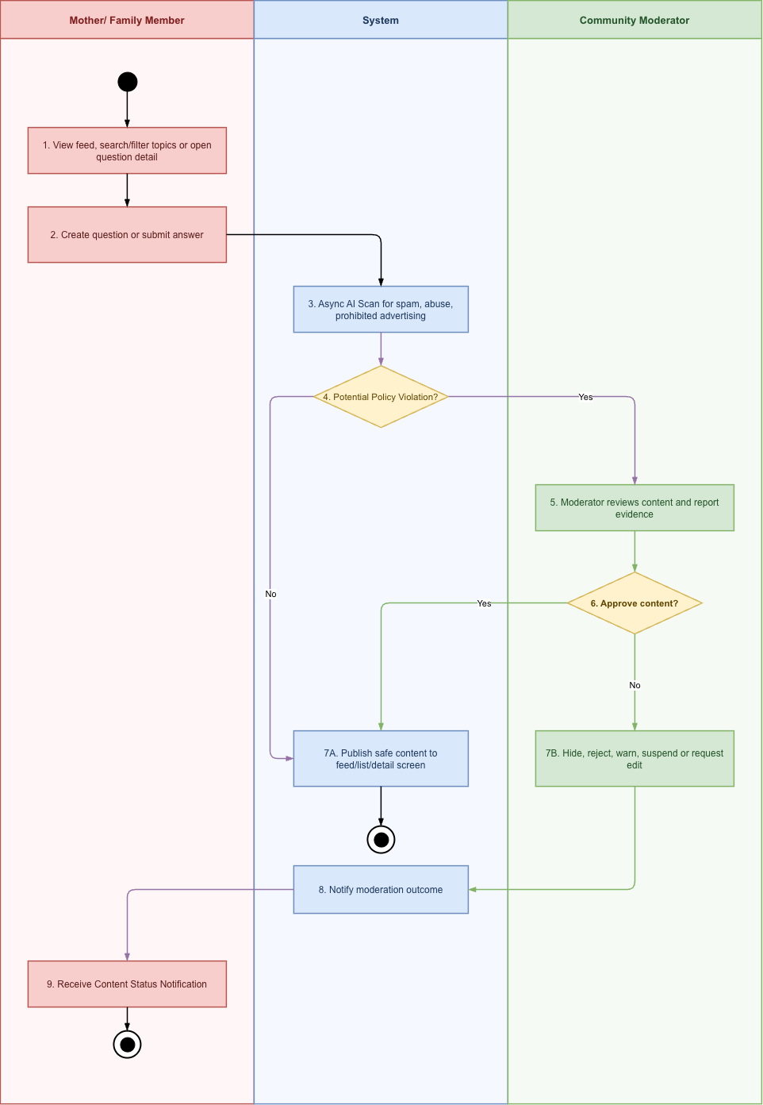
Image Detail: Community Q&A & Moderation Workflow

3.5.3 Step-by-Step User Guide for Mother, family
Step 1: Community Feed Screen
- Open Cộng đồng to view questions and answers from families and experts.
- Search or filter content by topic, life stage, or expert status.
- Select a question to read its details, or select Đặt câu hỏi to create a new question.
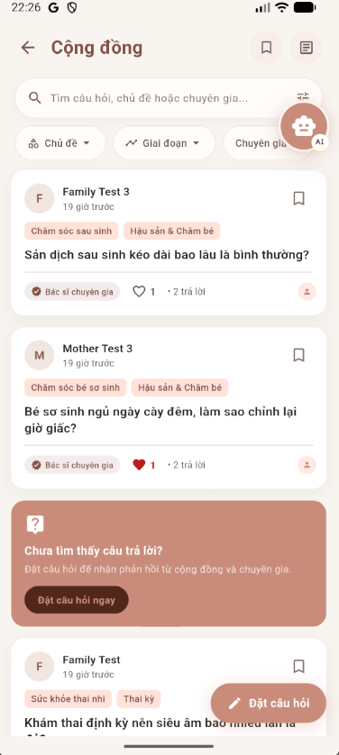
Step 2: Ask a Question Screen
- Enter the question title and detailed description.
- Add up to three images if needed, then select the topic, related life stage, and priority level.
- Enable anonymous posting when required and select Đăng câu hỏi to submit the question.
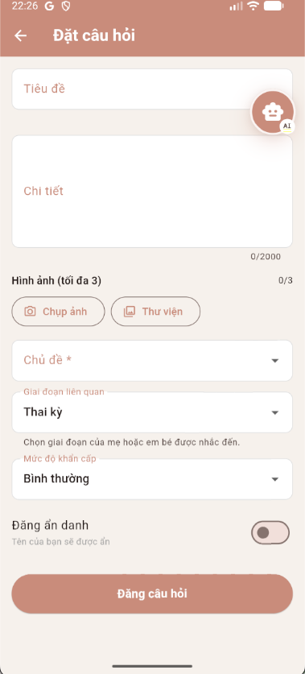
Step 3: Question Detail Screen
- Review the question content, topic, life stage, and existing answers.
- Read family and expert responses and use the available interaction options when appropriate.
- Select Trả lời ngay to write an answer to the question.

Step 4: Submit Answer Screen
- Review the safety notice before writing the response.
- Add relevant experience tags, write the answer, and attach up to three images if necessary.
- Select Đăng trả lời to submit the answer for review and publication.
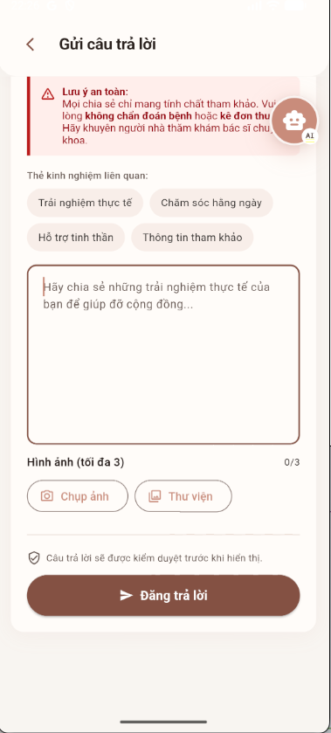

3.5.4 Step-by-Step User Guide for Moderator
Step 1: Pending Manual Review Screen
- Open Nội dung mới from the Moderator Portal navigation.
- Review content in the Câu hỏi mới, Câu trả lời mới, or Đã xử lý tabs.
- Select Xem to inspect the content, then select Duyệt, Ẩn, or Yêu cầu sửa according to the review result.
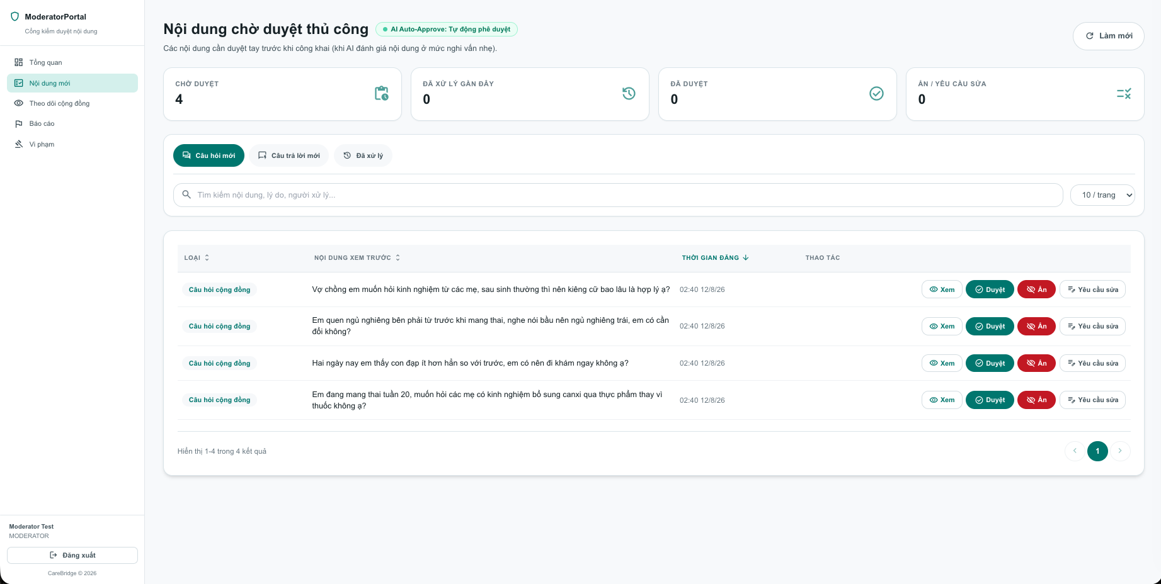
Step 2: Community Content Monitoring Screen
- Open Theo dõi cộng đồng to view questions and answers currently visible to the community.
- Switch between Câu hỏi đang hiển thị and Câu trả lời đang hiển thị.
- Select Xem đầy đủ to inspect the published content and verify that it remains appropriate.
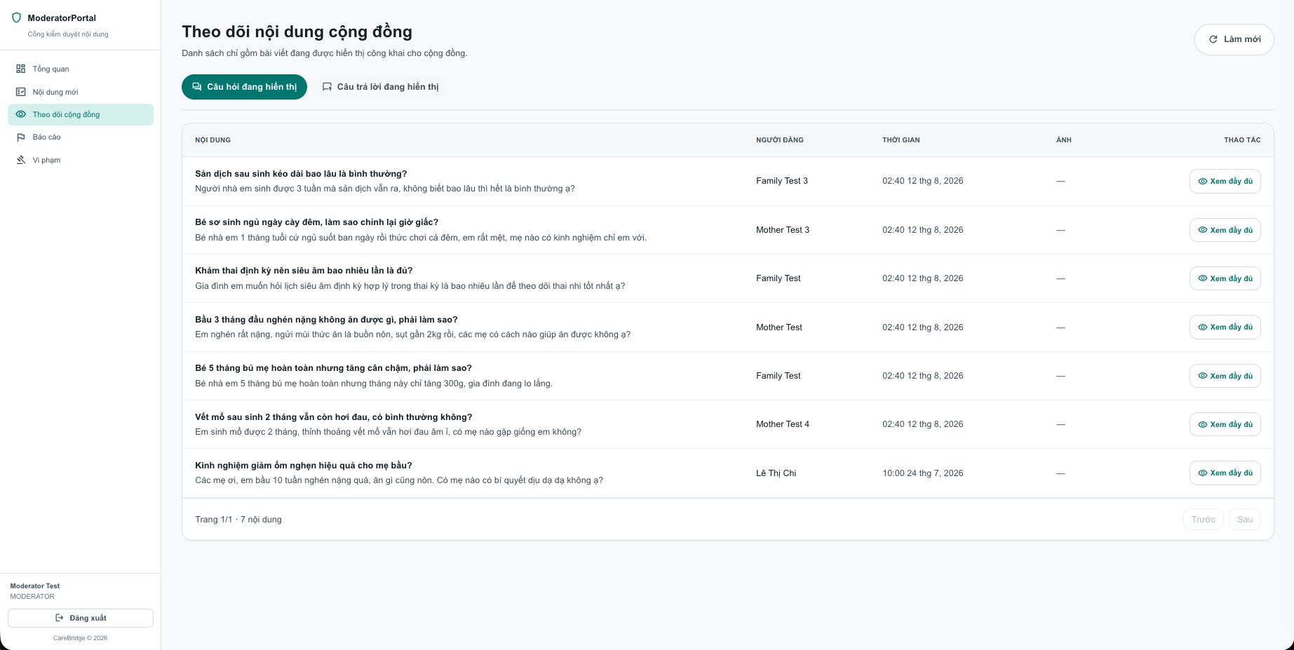
Step 3: Violation Reports List Screen
- Open Báo cáo to view reports submitted by users or detected by AI.
- Use the open or processed tabs, search field, and filters to find a report.
- Select Xem to review the report or Nhận xử lý to assign the report to yourself.
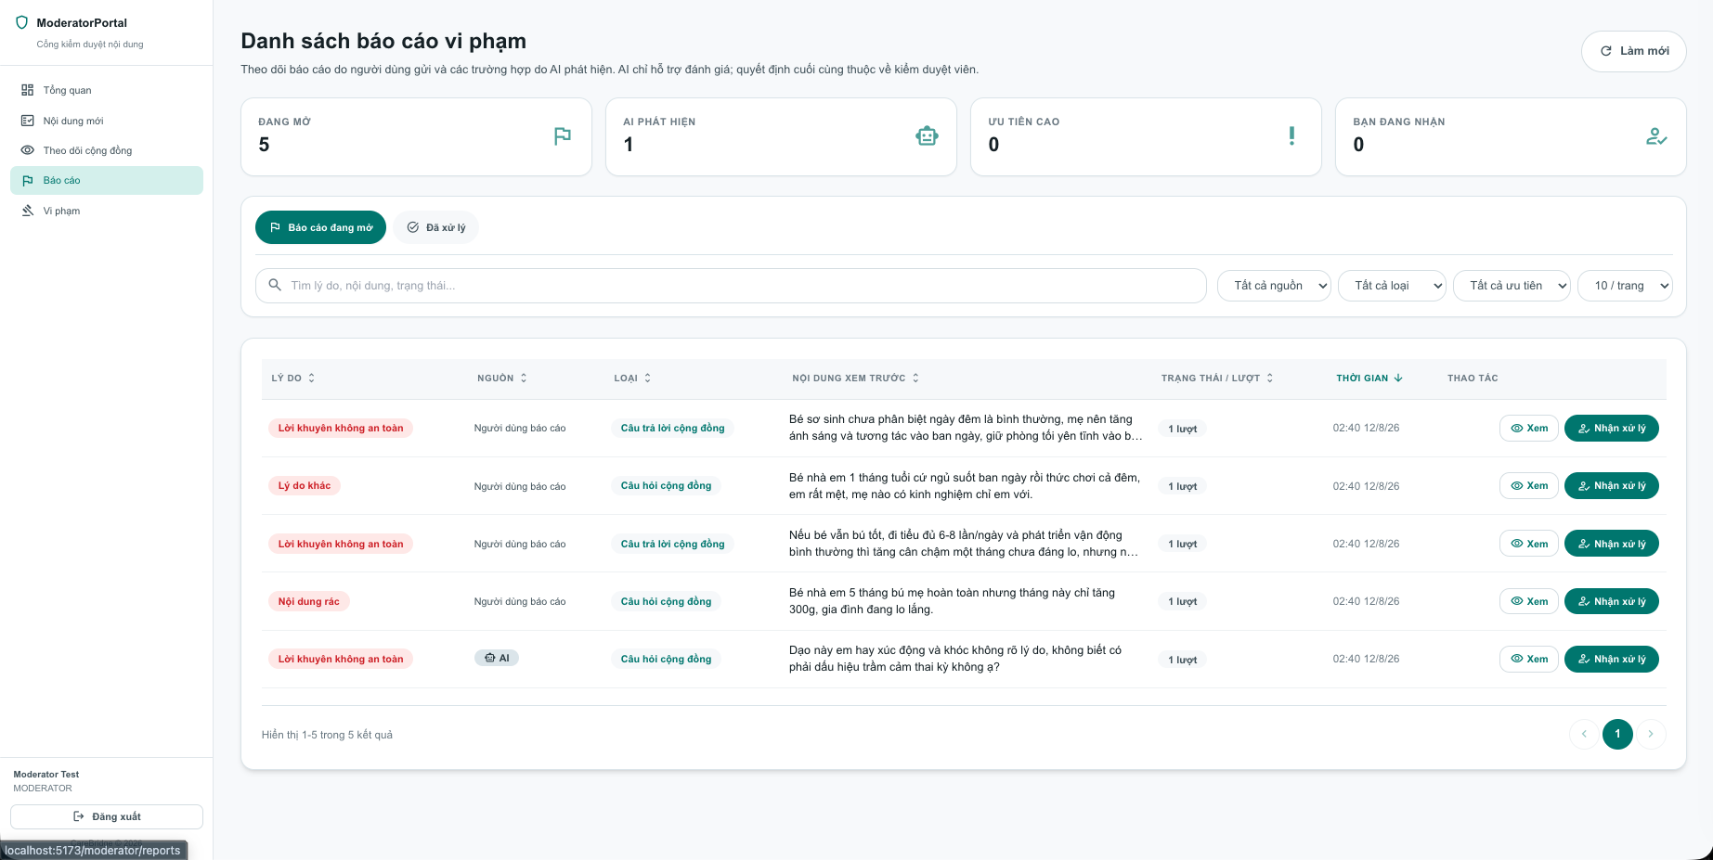
Step 4: Violation Report Detail Screen
- Review the report reason, reported content, reporter information, and report history.
- Select the appropriate moderation action, such as Duyệt nội dung, Xóa bài viết, Ẩn nội dung, Yêu cầu sửa, Cảnh cáo người dùng, Hạn chế đăng, or Đình chỉ.
- Add an optional processing note and confirm the decision.
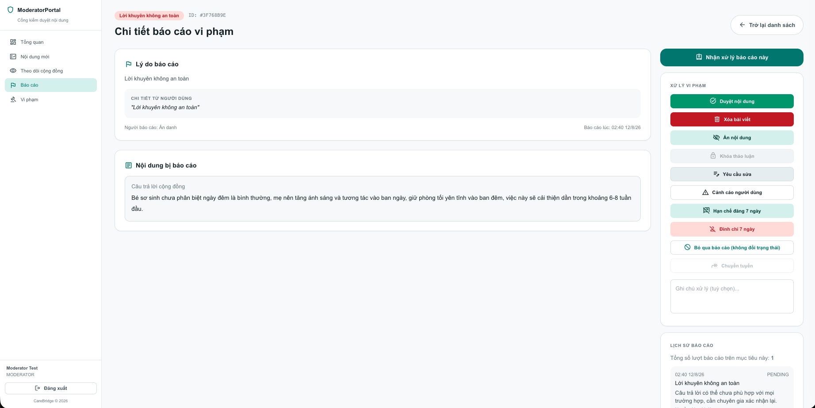

3.6 Verified Expert Network & Contribution

3.6.1 Purpose of this Workflow:
This guide explains the process for healthcare professionals to submit identity and professional credential verification details and complete the administrative review, as well as how to use the (verified) Professional Portal to manage professional information, consultation sessions, schedules, and community contribution activities.
It also outlines the procedure for resubmitting information if data is incomplete or rejected, and explains the impact of policy violations or expired practice licenses on verification status and contribution privileges.

3.6.2 Workflow Diagram:
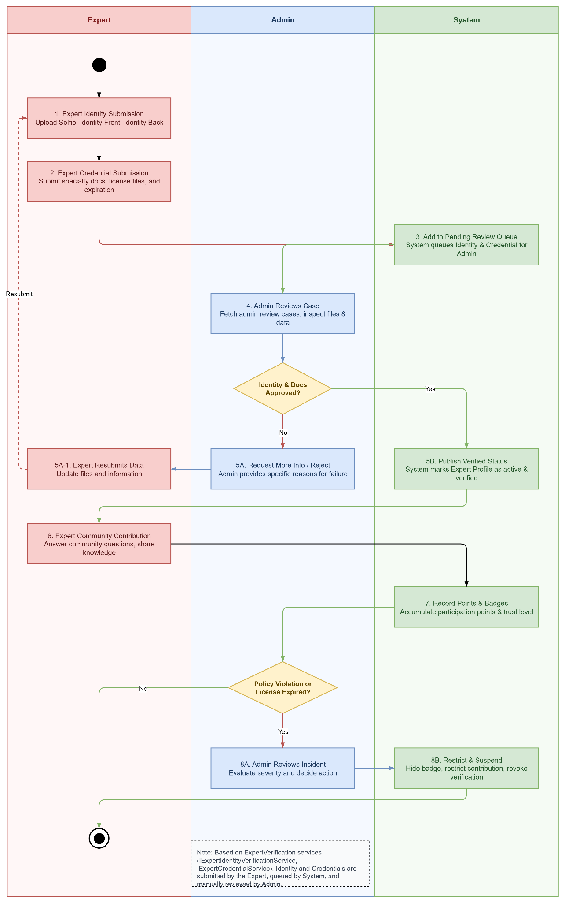
Image Detail: Verified Expert Network & Contribution Workflow

3.6.3 Step-by-Step User Guide on the Web:
Step 1: Identity Verification Screen
- Sign in to ExpertPortal and open Xác minh Y tế.
- Upload a portrait photo, the front of the identity card, and the back of the identity card using Chụp ảnh or Chọn tệp.
- Select Hoàn tất & Gửi hồ sơ to submit the identity information for review.
If Admin requests more information, update the required files and resubmit the application.
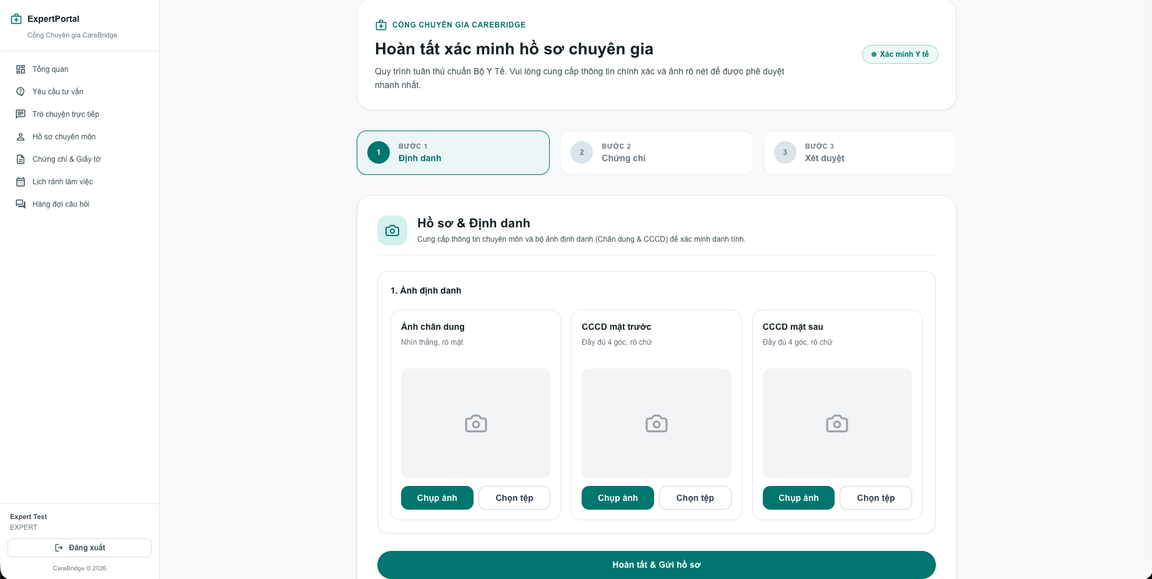
Step 2: Verification Completed Screen
- After the identity and credential review is approved, open the verification result screen.
- Confirm that all three verification stages are completed and the status shows Hồ sơ đã được xác minh.
- Select Vào Trang chủ Chuyên gia to access the verified Expert Portal.
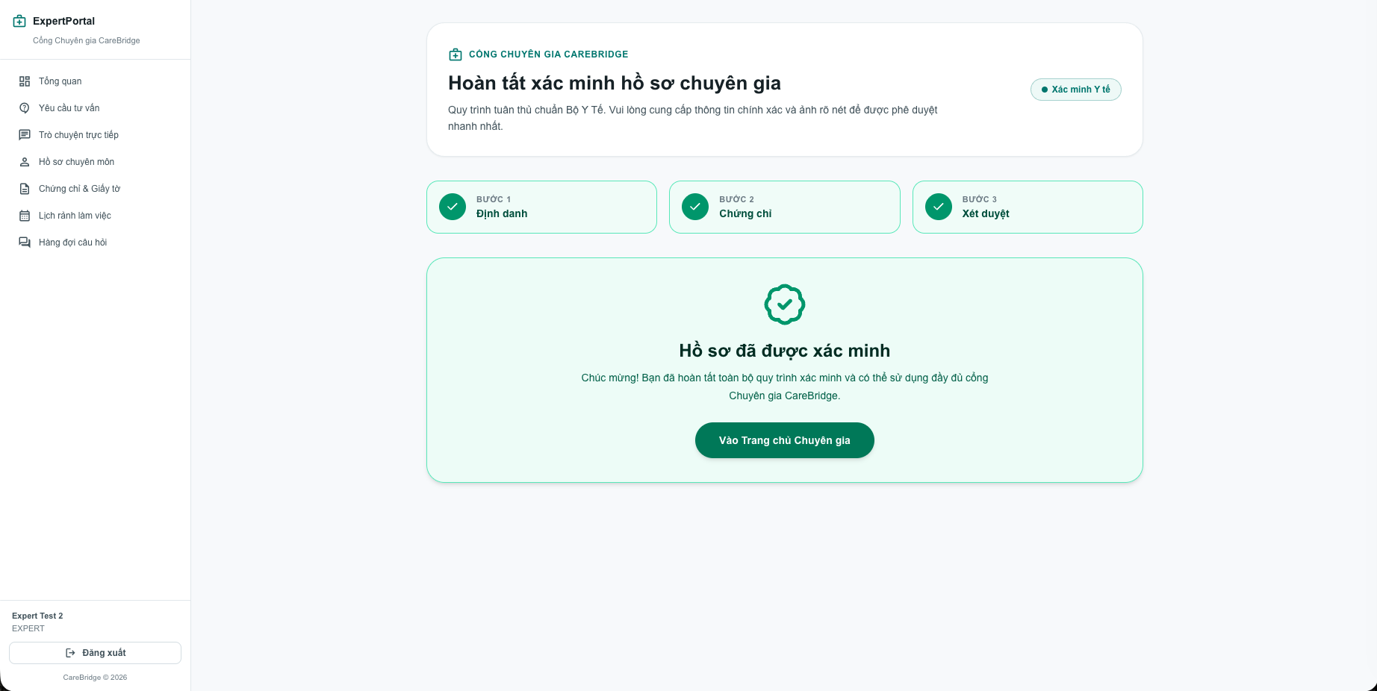
Step 3: Consultation Requests Screen
- Select Yêu cầu tư vấn from the left navigation.
- Review the sender, consultation topic, status, and submission time.
- Accept or decline a request, then select Vào nhắn tin for an accepted consultation.
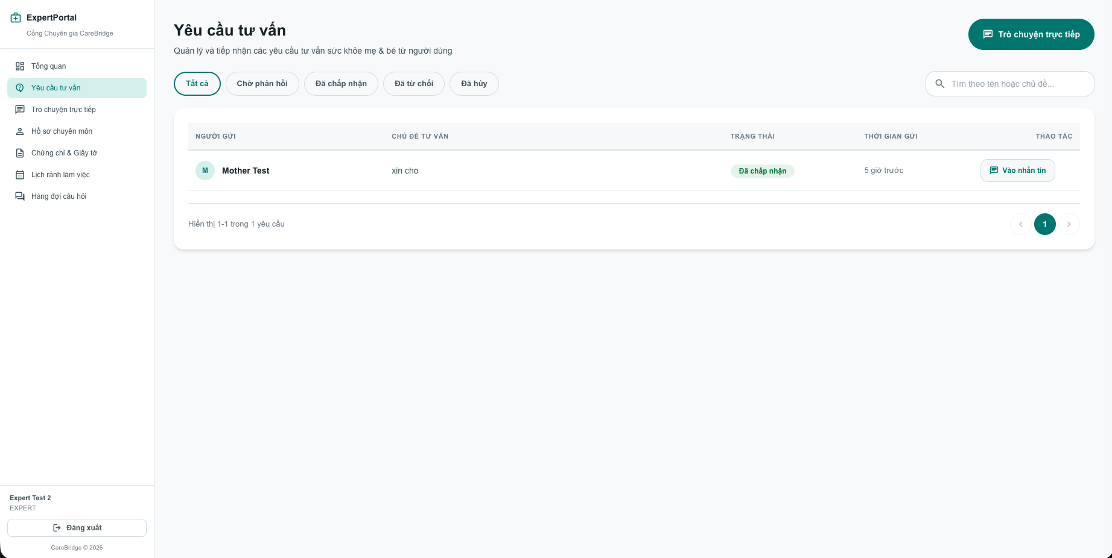
Step 4: Live Chat Screen
- Open an accepted consultation from the request list.
- Type a response in the message field and select the send button.
- Use Gọi thoại, Gọi video, or the attachment buttons when additional communication is needed.
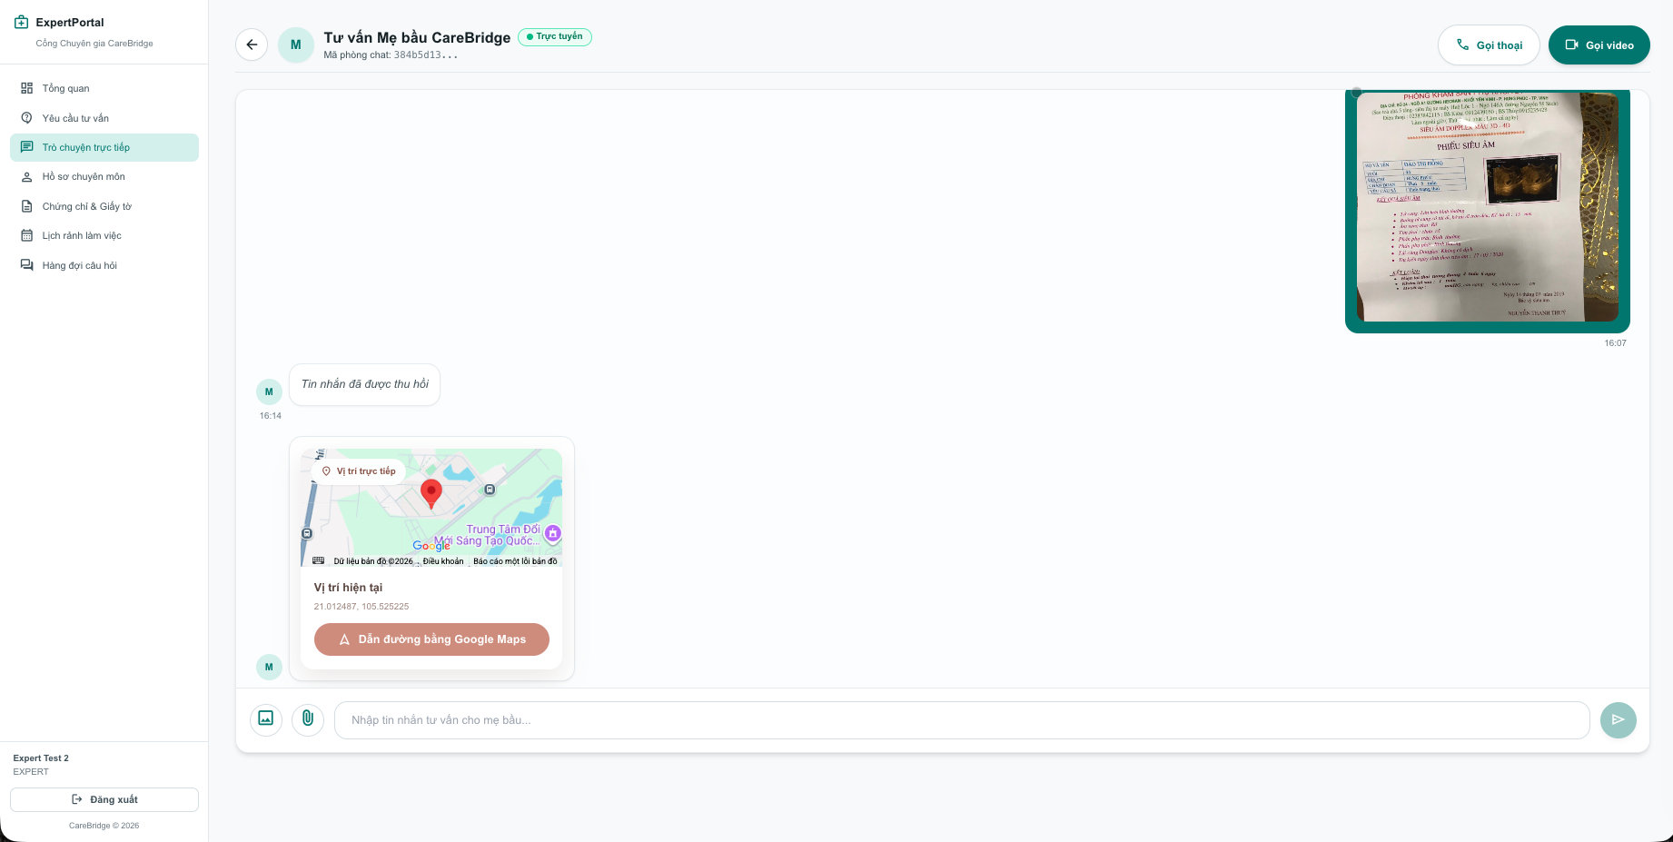
Step 5: Professional Profile Screen
- Select Hồ sơ chuyên môn.
- Review or update the specialty, professional title, years of experience, workplace, and consultation scope.
- Save the changes or select Cập nhật ảnh to update the profile photo.
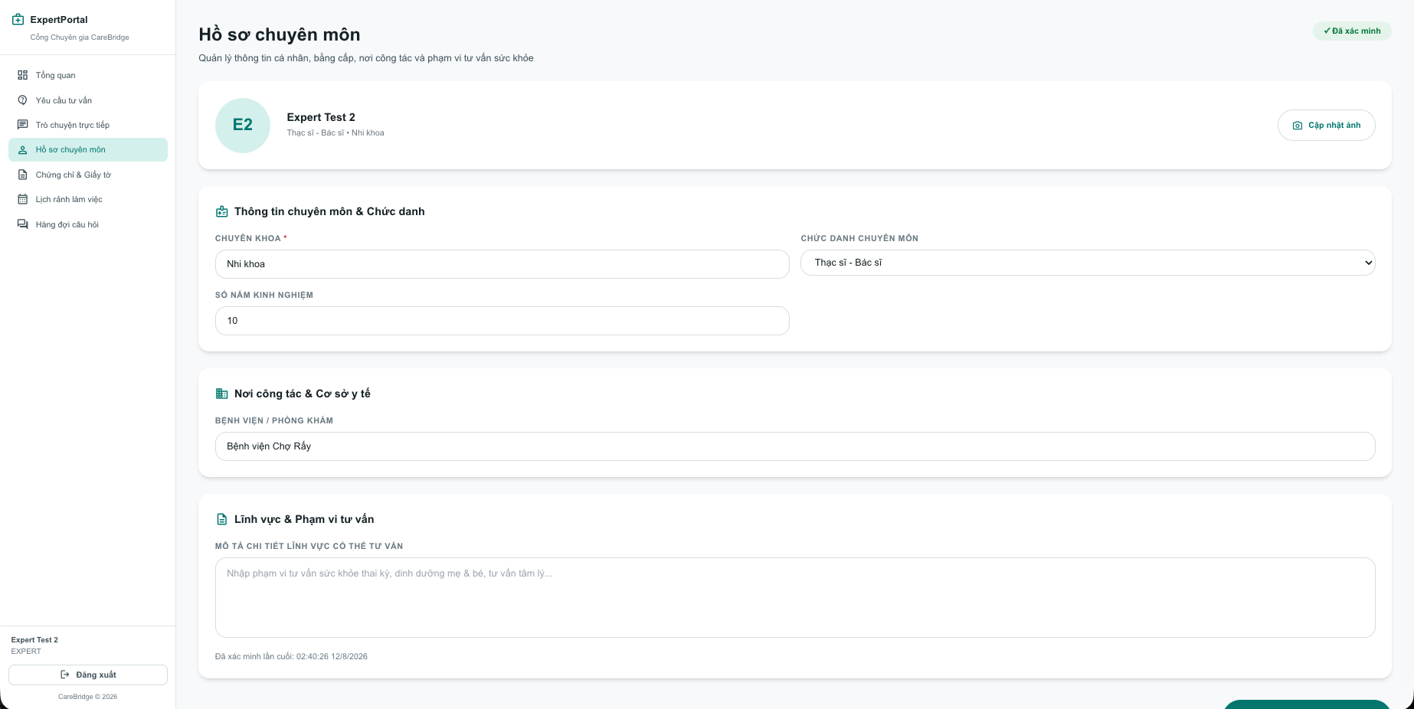
Step 6: Certificates & Documents Screen
- Select Chứng chỉ & Giấy tờ.
- Review certificate status, issuing authority, issue date, and expiration date.
- Select Tải lên chứng chỉ mới to submit a new or renewed professional document.
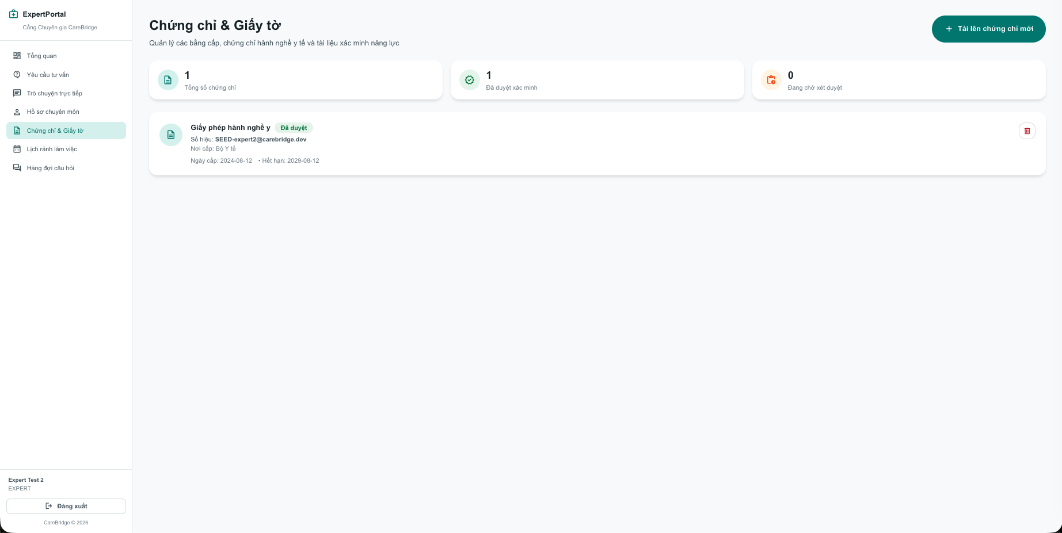
Step 7: Working Schedule Screen
- Select Lịch rảnh làm việc.
- Use the calendar controls to navigate to the required date or month.
- Add or review available consultation sessions so families can book an appropriate time.
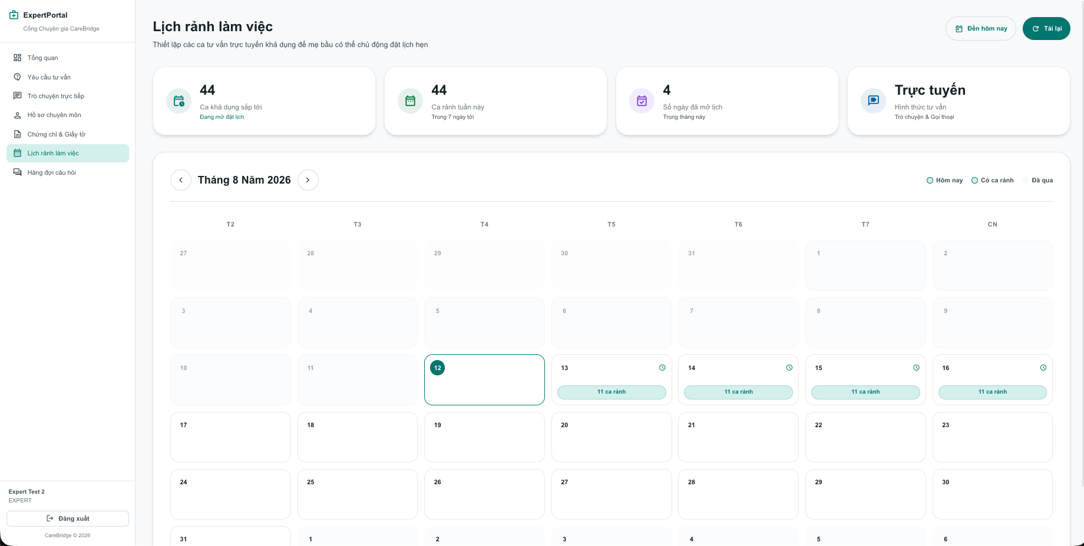
Step 8: Community Question Queue Screen
- Select Hàng đợi câu hỏi.
- Choose a question and review its topic, life stage, priority, and existing answers.
- Write an expert response and select Gửi câu trả lời.
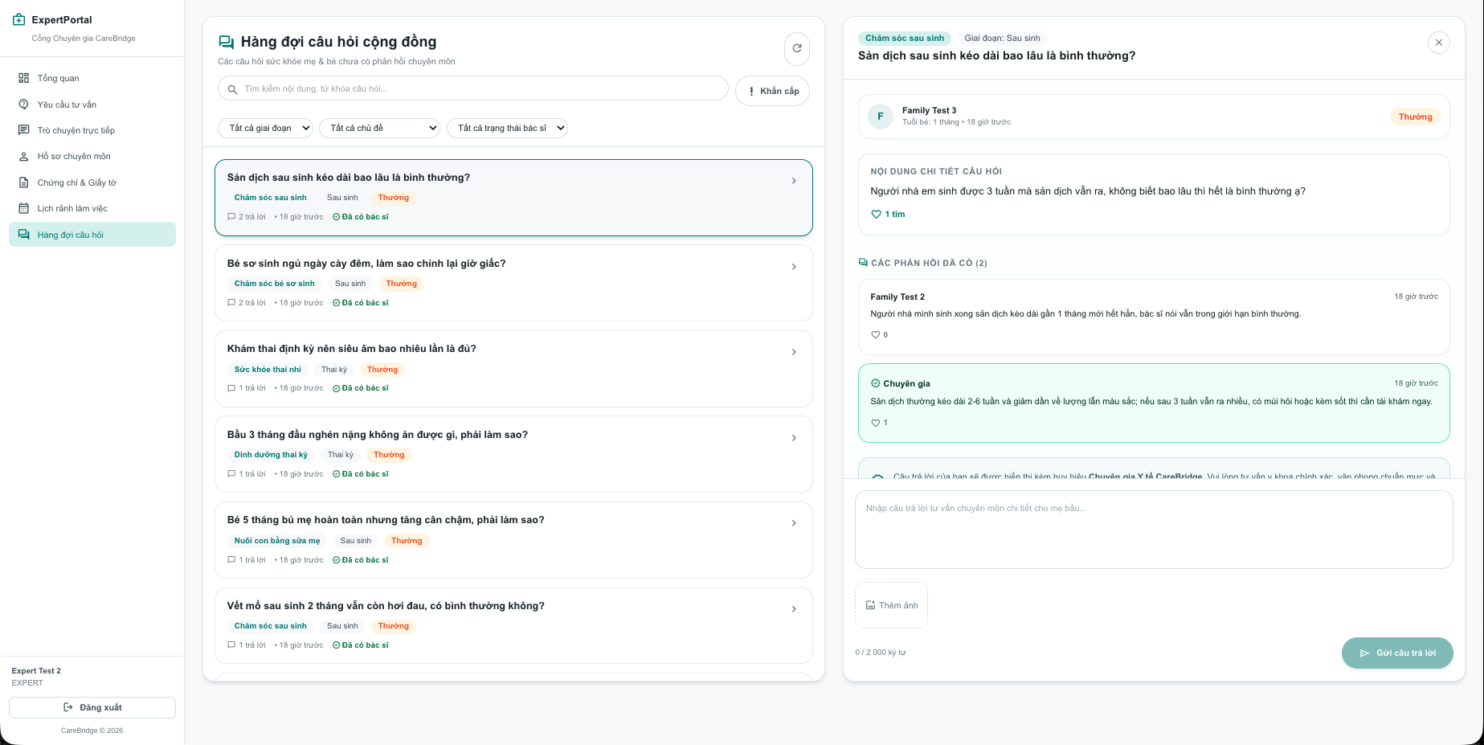

3.6.4 Step-by-Step User Guide on the Mobile app:
Step 1: Expert Registration Screen
- Enter the expert's name, email, phone number, and password.
- Confirm the password requirements.
- Select Tạo tài khoản to create the expert account.
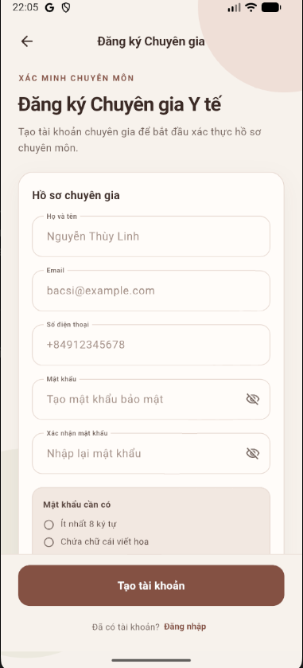
Step 2: Identity Verification Screen
- Capture or upload a live portrait photo.
- Capture or upload the front and back of the identity card.
- Select Gửi ảnh xác minh to submit the identity information for verification.
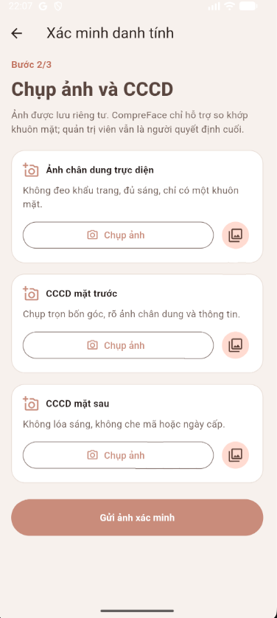
Step 3: Expert Dashboard Screen
- Review the number of consultation requests and new community questions.
- Select Yêu cầu tư vấn to manage consultations or Cộng đồng Mẹ & Chuyên gia to view community questions.
- Use the bottom navigation to access the dashboard, chat, requests, schedule, and account sections.
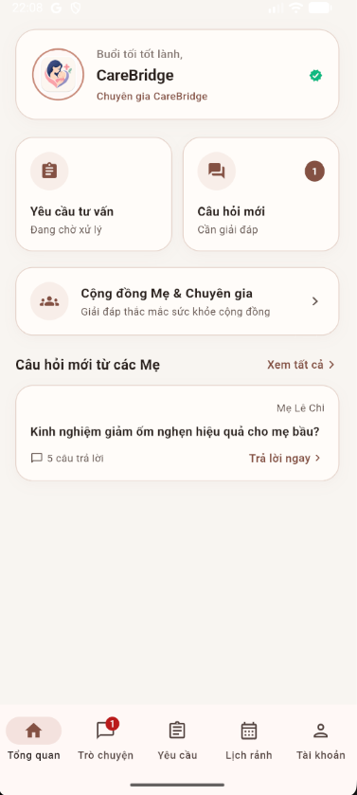
Step 4: Consultation Requests Screen
- Open Yêu cầu tư vấn from the dashboard or bottom navigation.
- Use the status tabs to view pending, accepted, or rejected requests.
- Select an available request to review and respond to the consultation.
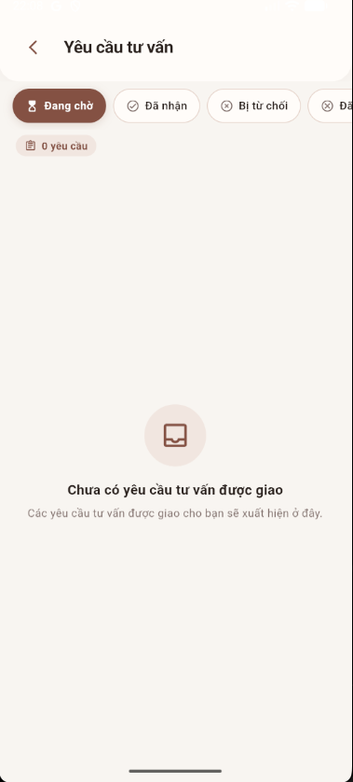
Step 5: Community Screen
- Open Cộng đồng to view questions from families.
- Search or filter questions by topic, life stage, or expert status.
- Select a question to read the discussion and provide an expert answer.
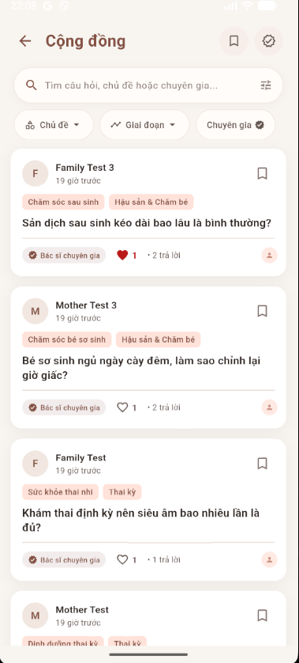
Step 6: Live Chat Screen
- Open a consultation conversation from the chat or request section.
- Send messages and share images or location information when necessary.
- Use the phone or video call options for direct communication with the family.
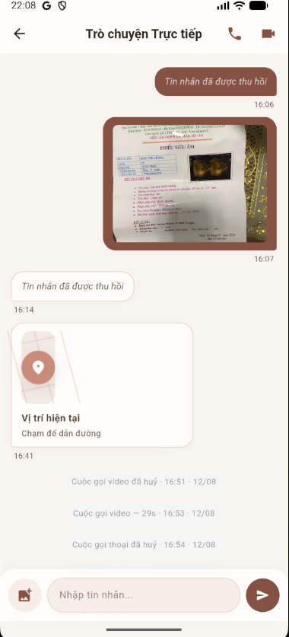
Step 7: Working Schedule Screen
- Open Lịch rảnh from the bottom navigation.
- Select a date from the calendar.
- Add or review available consultation time slots and save the schedule.
